**Uncovering the Gaming Industry's Hidden Gems: A**

**Comprehensive Analysis of Video Game Sales**

1. **Introduction**

A **video game** is an [electronic game](https://en.m.wikipedia.org/wiki/Electronic_game) that involves interaction with a [user interface](https://en.m.wikipedia.org/wiki/User_interface) or [input device](https://en.m.wikipedia.org/wiki/Input_device) (such as a [joystick](https://en.m.wikipedia.org/wiki/Joystick), [controller](https://en.m.wikipedia.org/wiki/Game_controller), [keyboard](https://en.m.wikipedia.org/wiki/Computer_keyboard), or [motion sensing](https://en.m.wikipedia.org/wiki/Motion_sensing) device) to generate [visual](https://en.m.wikipedia.org/wiki/Visual) [feedback](https://en.m.wikipedia.org/wiki/Feedback) from a [display device](https://en.m.wikipedia.org/wiki/Display_device), most commonly shown in a [video](https://en.m.wikipedia.org/wiki/Video) format on a [television set](https://en.m.wikipedia.org/wiki/Television_set), [computer monitor](https://en.m.wikipedia.org/wiki/Computer_monitor), [flat-panel display](https://en.m.wikipedia.org/wiki/Flat-panel_display) or [touch screen](https://en.m.wikipedia.org/wiki/Touchscreen) on [handheld devices](https://en.m.wikipedia.org/wiki/Handheld_device), or a [virtual reality headset](https://en.m.wikipedia.org/wiki/Virtual_reality_headset), hence the name..

1.1-Overview

Video games are popular all over the world. They are enjoyed by all ages. Video game industry is huge and the spending on video games per year is huge too. Sales of different types of games vary widely between countries due to local preferences. According to the market research firm Super Data, as of May 2015, the global games market was worth USD 74.2 billion. By region, North America accounted for 23.6 billion dollars, Asia for 23.1 billion dollars, Europe for 22.1 billion dollars and South America for 4.5 billion dollars. There are different genres, publisher and platforms for video games. This project relates to the sales of these video games based on different regions and analyzes the sales. Also I have analyzed which genre, platform or publisher is the most popular and has maximum number of sales.

1.2-Purpose

In this the main goal was to analyze the sales of video games in different regions. The regions are North America, Europe, Japan, other countries (combined) and then the global sales (total of all the regions). The main idea was to visualize the sales for different genres, publishers and platforms. This would give the basic idea about the most popular genres, publishers and platforms amongst all. Also analyzing the effect of genres on sales in different regions.

1. **Problem Definition & Design Thinking**

Video game sales analysis is the process of collecting and analyzing data about the sales of video

games in order to understand market trends and consumer behavior. This type of analysis can be

useful for a variety of purposes, including identifying the most popular games and genres, predicting

future sales, and developing marketing strategies.Video game sales analysis typically involves

collecting data from Kaggle sources. It was generated by a scrape of vgchartz.com. This data may

include information about the number of units sold, the retail price, and the platforms on which the

games are played. Once the data has been collected, it is typically analyzed using tableau. The

results of the analysis can be used to identify trends and patterns in the market, and to make informed

decisions about the development and marketing of video games.Video game sales analysis may be

conducted by game developers, publishers, retailers, and other industry professionals. It is an

important part of the video game industry, as it helps to understand the needs and preferences of

consumers and to identify opportunities for growth and innovation.

2.1-Empathy Map

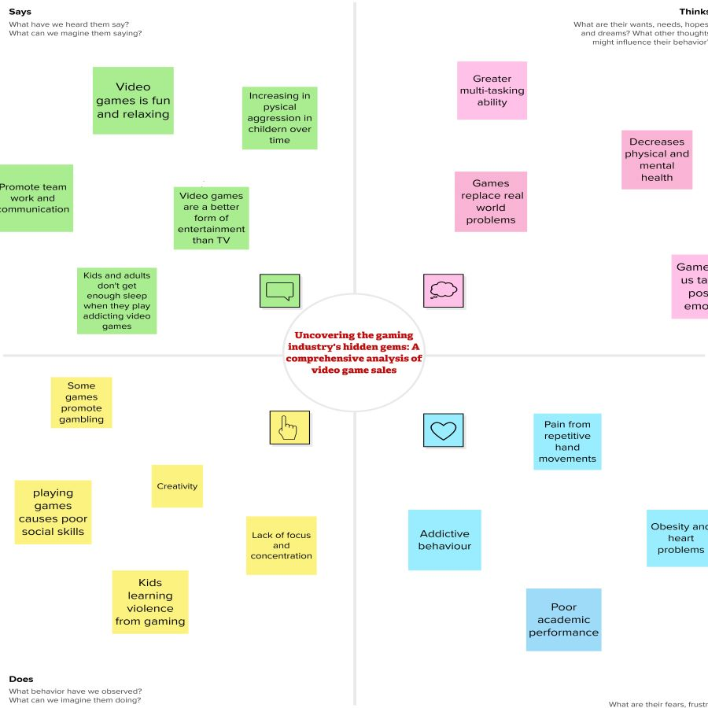

2.2-Ideation & Brain Storming Map

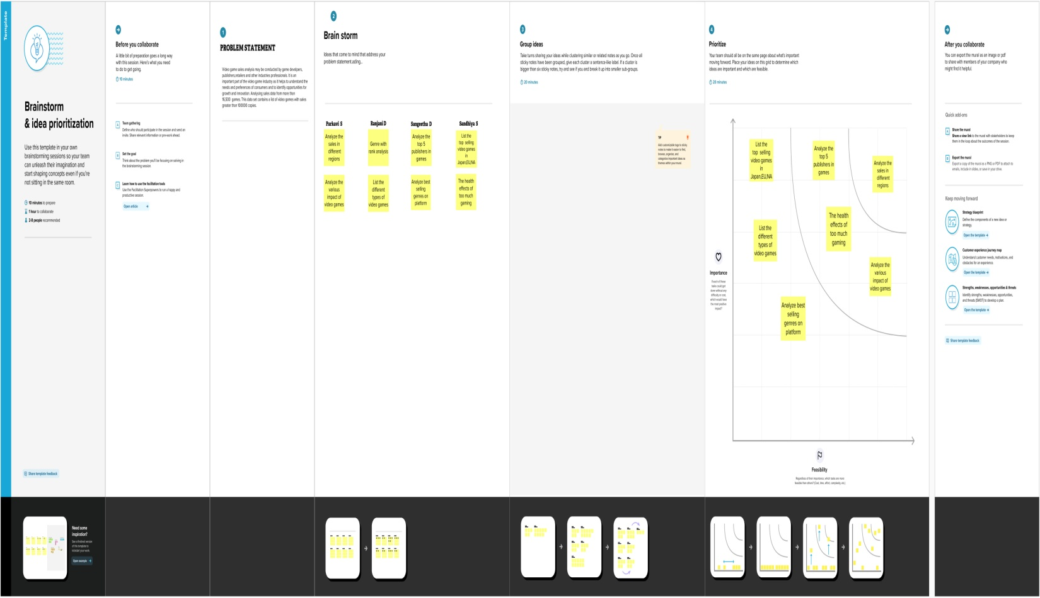

1. **Results**

3.1-Data Collection & Extraction from Database

For this project the data was collected from Kaggle(www.kaggle.com). This data gives us the idea about the sales of video games in different regions of the world. The distribution is with respect to genres, publishers and platforms.

Rank: Ranking of overall sales

Name: Name of the video game

Platform: Platform on which the game was released or is playable

Year: Year in which the game was released

Genre: Genre the game belongs to

Publisher: Name of the publisher who created the game

NA_Sales: Sales in North America

EU_Sales: Sales in Europe

JP_Sales: Sales in Japan

Other_Sales: Sales in other countries

Global_Sales: Global Sales

3.2-Data Visualization

The number of unique visualizations that can be created with a given dataset. Some common

types of visualizations that can be used to analyze the performance and efficiency of

Radisson Hotels include bar charts, line charts, heat maps, scatter plots, pie charts,Maps etc.

These visualizations can be used to compare performance, track changes over time, show

distribution, and relationships between variables, breakdown of revenue and customer

demographics, workload, resource allocation and location of sales of Games.

3.2.1-Sales in different region Analysis

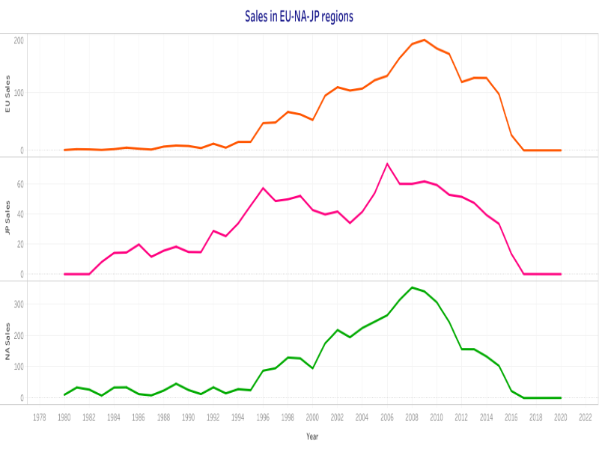

3.2.2-Genre with rank Analysis

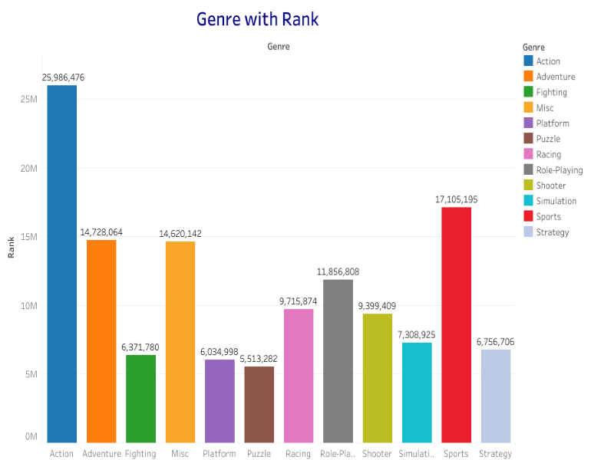

3.2.3-Total Sales Analysis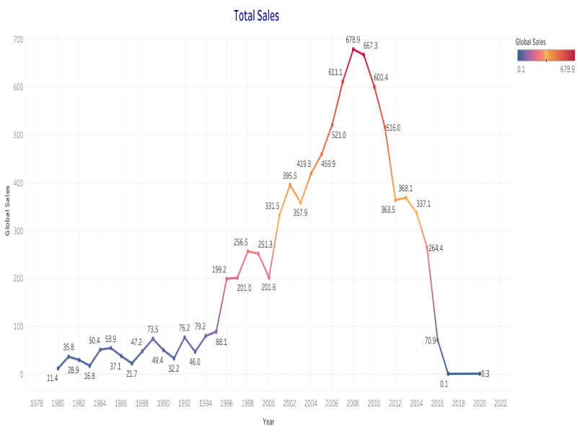

3.2.4-Top 5 publishers Analysis

3.2.4-Top 5 Publishers Analysis

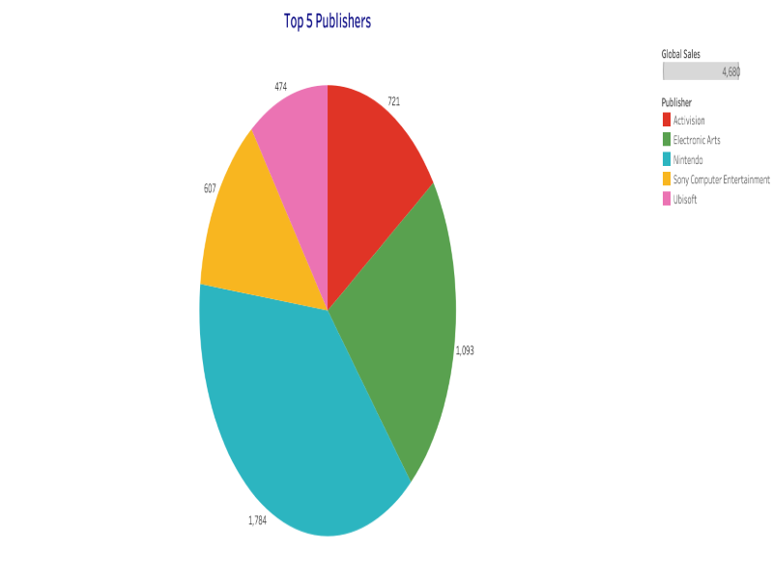

3.2.5-Best 10 selling genres on platform Analysis

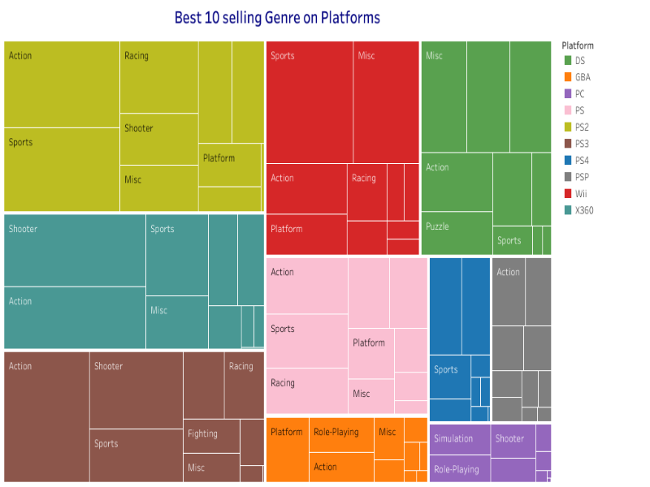

3.2.6-Top 10 EU selling video games Analysis

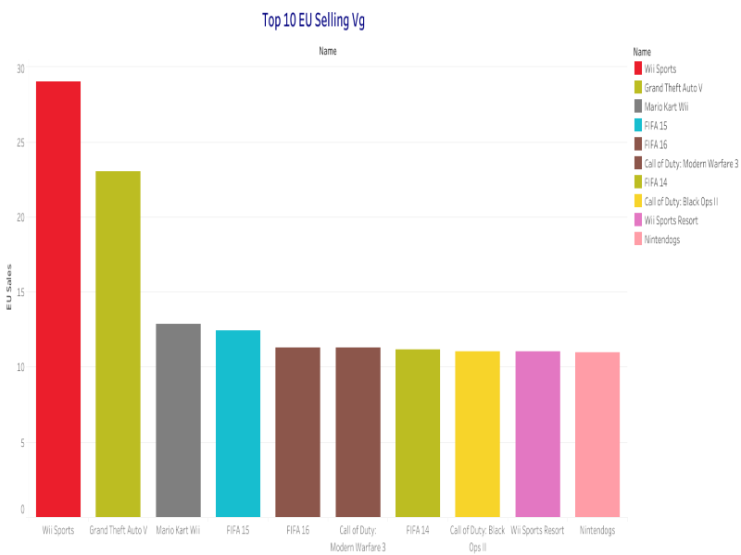

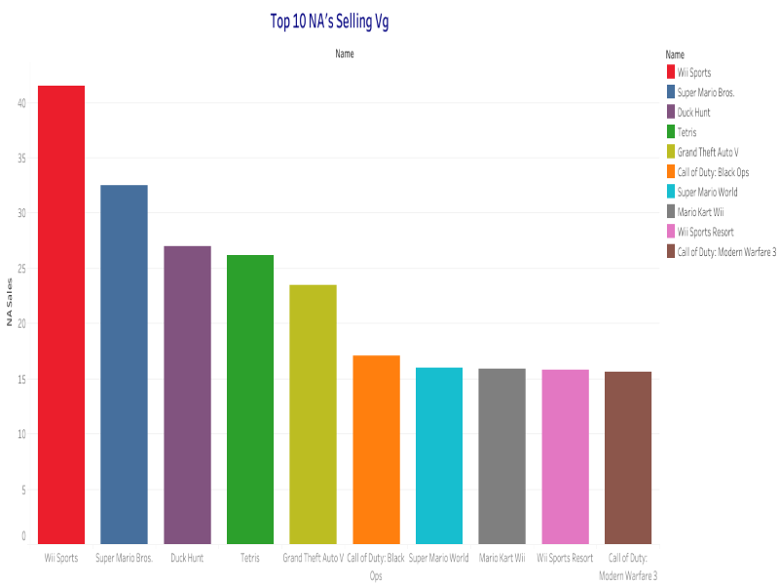3.2.7- Top 10 NA selling video games Analysis

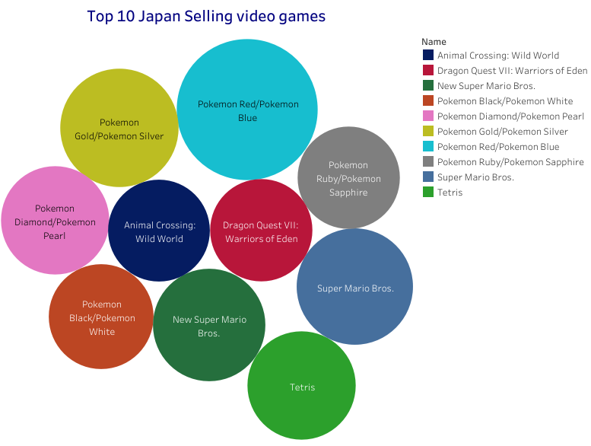3.2.8- Top 10 Japan selling video games Analysis

3. 3.3-Dashboard

3.3-Dashboard

A dashboard is a graphical user interface (GUI) that displays information and data in an organized,

easy-to-read format. Dashboards are often used to provide real-time monitoring and analysis of data,

and are typically designed for a specific purpose or use case. Dashboards can be used in a variety of

settings, such as business, finance, manufacturing, healthcare, and many other industries. They can

be used to track key performance indicators (KPIs), monitor performance metrics, and display data in

the form of charts, graphs, and tables.

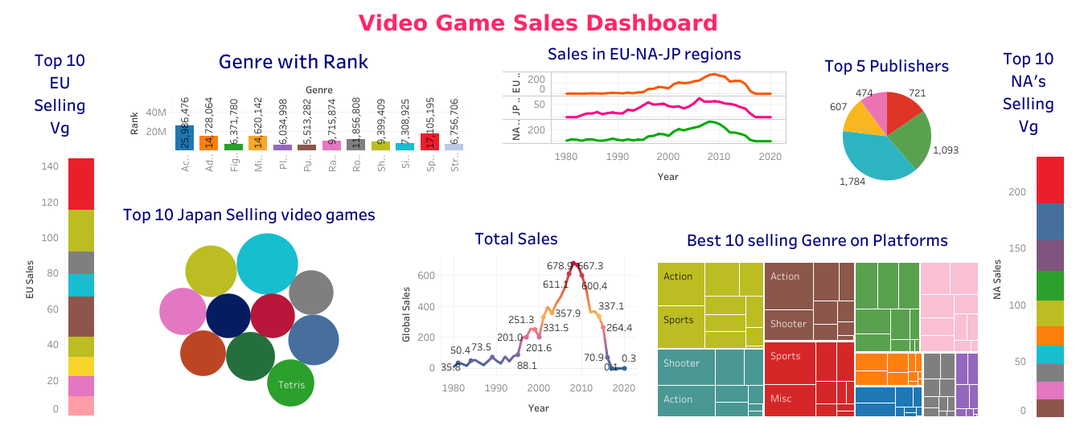

3.4-Story

A data story is a way of presenting data and analysis in a narrative format, with the goal of making the information more engaging and easier to understand. A data story typically includes a clear

introduction that sets the stage and explains the context for the data, a body that presents the data

and analysis in a logical and systematic way, and a conclusion that summarizes the key findings and

highlights their implications. Data stories can be told using a variety of mediums, such as reports,

presentations, interactive visualizations, and videos.

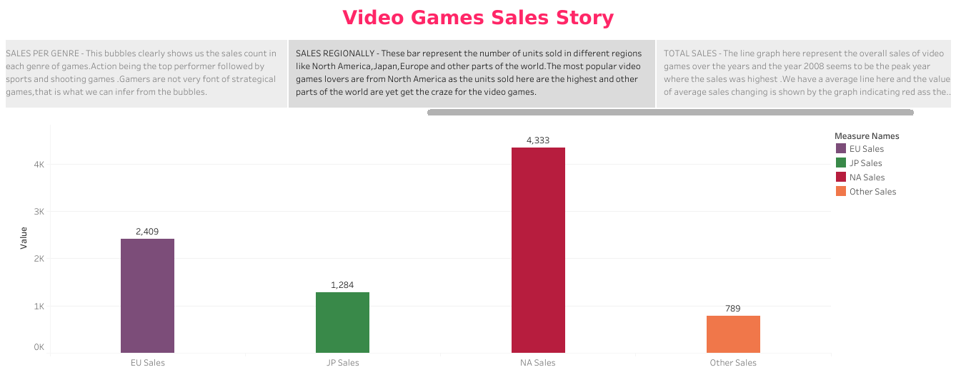

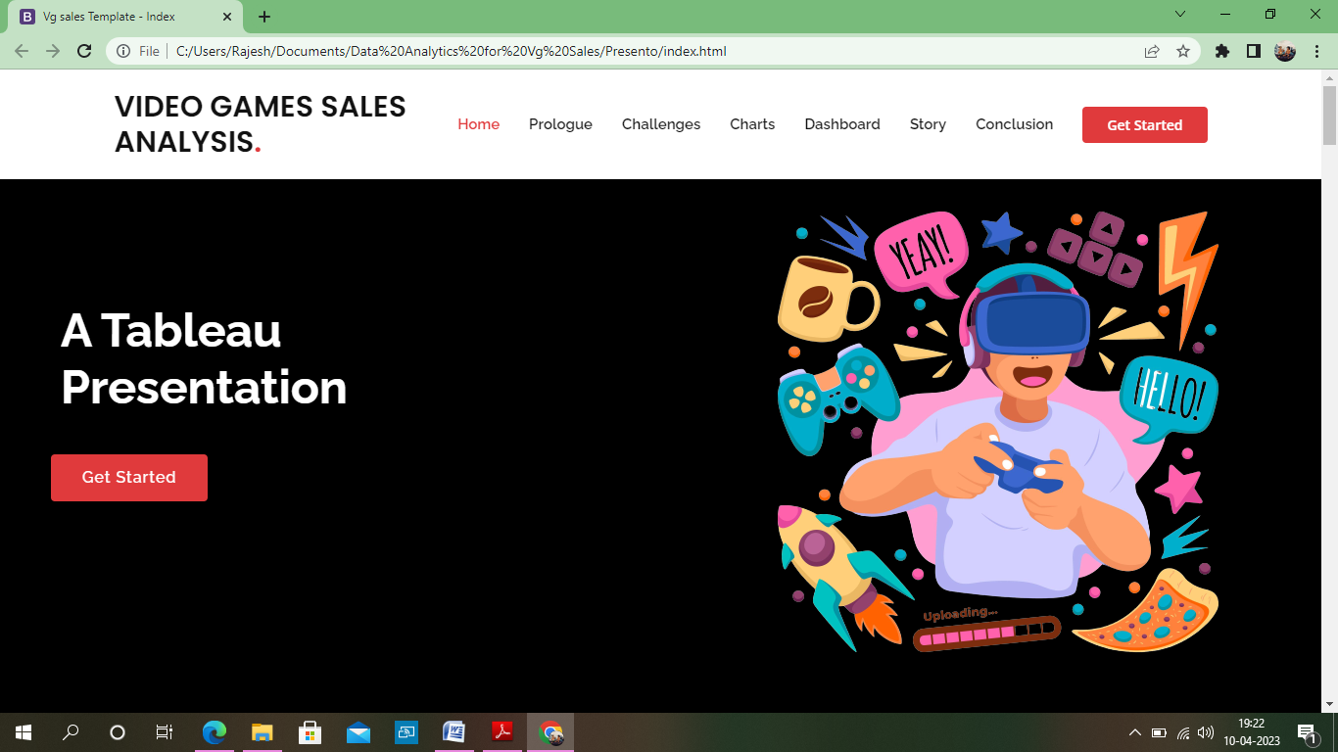3.5-Web Integration

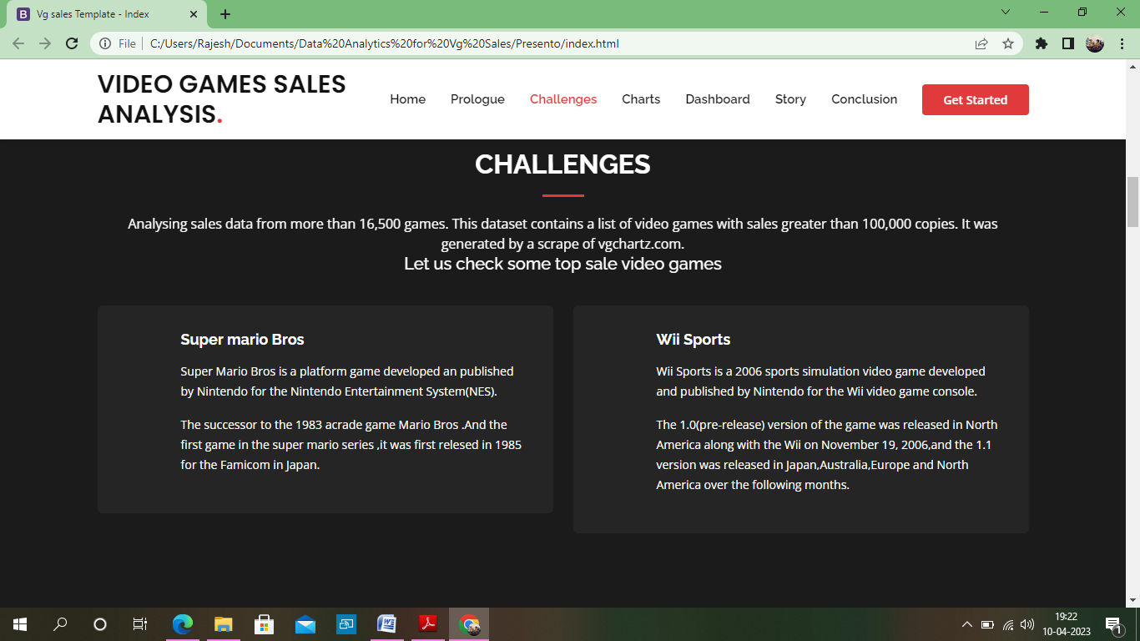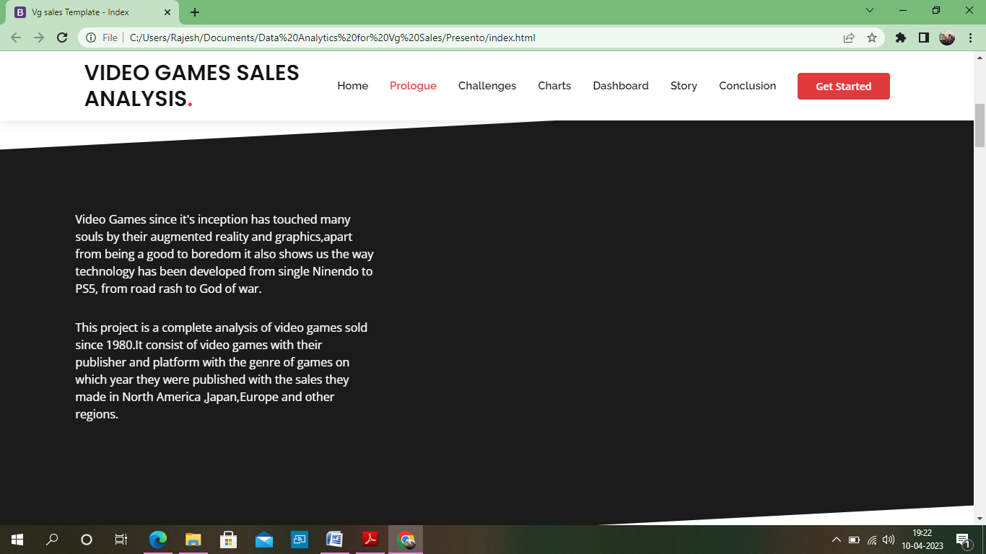

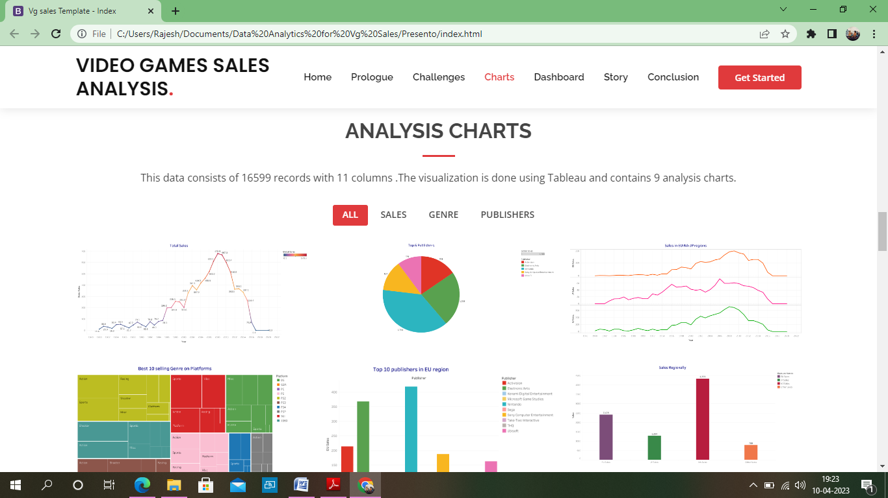

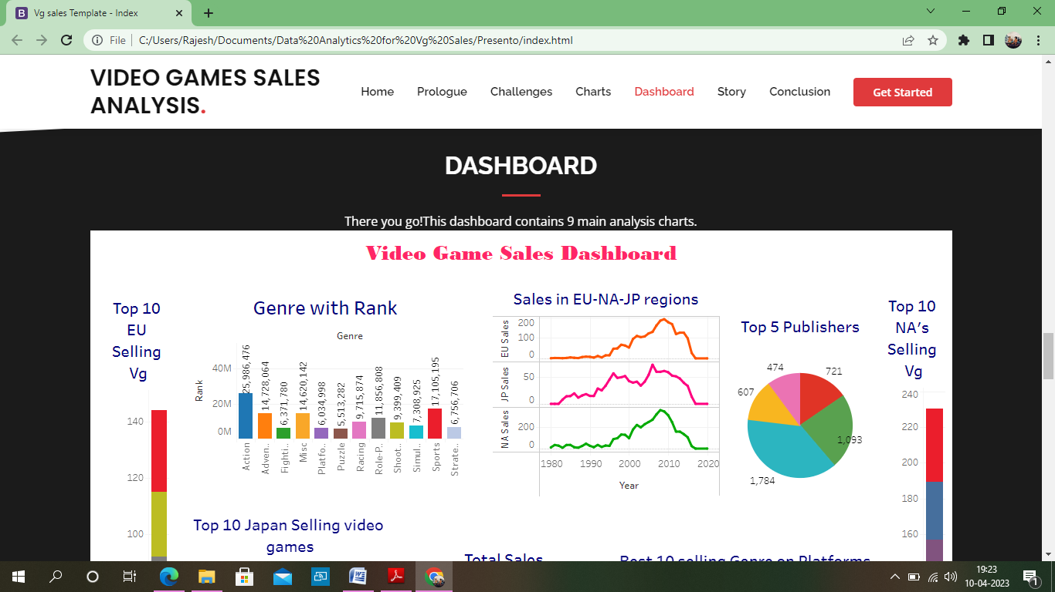

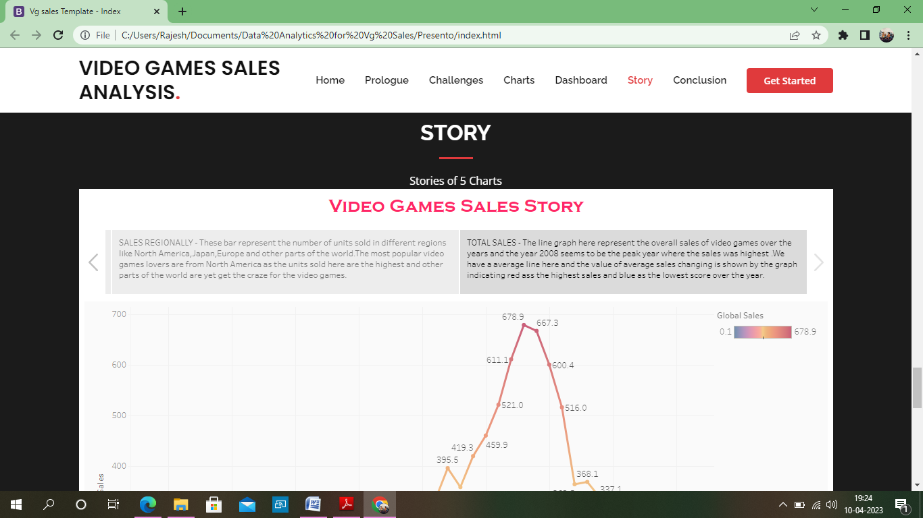

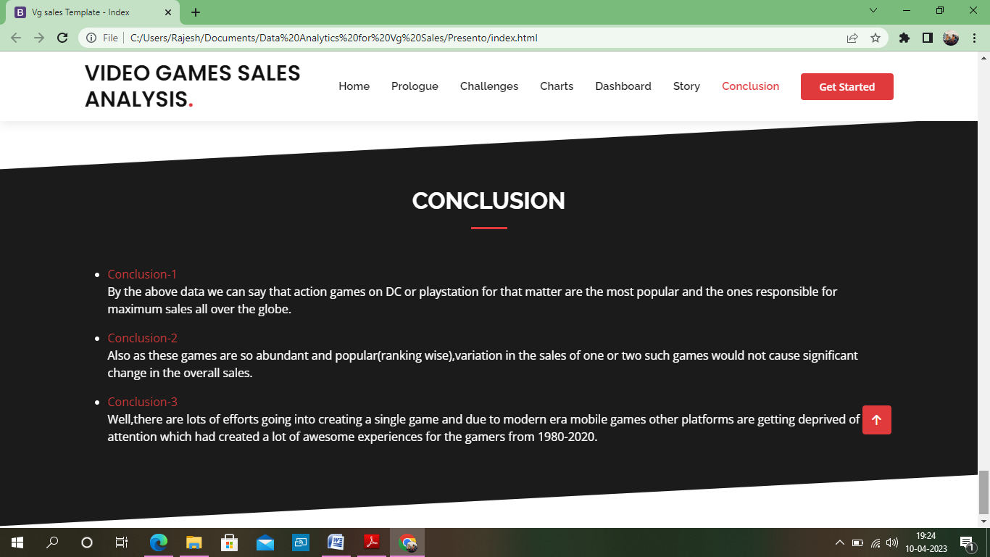

By the above data visualizations we can say that action games on DC or playstation for that matter are the most popular and are the ones responsible for maximum sales all over the globe. Also as these games are so abundant and popular (ranking wise), variation in the sales of one or two such games would not cause significant change in the overall sales.

1. **ADVANTAGES & DISADVANTAGES**

[Video games have become a staple in our modern, technologically driven culture](https://honestproscons.com/what-is-digital-technology-25-best-examples/). While kids have been crazy about these for decades, the introduction of [smart phones](https://honestproscons.com/advantages-and-disadvantages-of-smartphones/) and mobile gaming systems has pushed them to new heights.



Often based on fantasy, they also reflect both history and current events. But whether it’s a good or bad thing is up for debate. Even though video games are a household name today, they were born in the research labs of scientists.

4.1-Advantages of Video Games

Even though video games are demonized by most non-players, many scientists and psychologists find that video games can have many benefits. Some of them are explained below.

***1. Improved Vision***

Studies suggest that video game players may get an unexpected benefit from them; better vision. They have been shown to increase players’ ability to distinguish subtle differences in shades of gray.

They may also help players increase their ability to visually detect the direction of movement. It was found that gamers spotted targets on a cluttered screen 80% of the time, while non-gamers managed this only 30% of the time.

### *2. Brain Booster*

Playing video games directly impacts regions of the brain responsible for memory, spatial orientation, information organizations, and fine motor skills. As people age, the importance of playing games tends to increase. It could improve decision-making skills; compared to non-players, gamers who spend time daily with fast-paced games can react to questions or situations up to 25% faster.

### *3. Improved Life Skills*

Video games involve taking risks, and the ability to strategize. It teaches patience, perseverance, and the right judgment. It also helps people find new friends and social connections. Besides, gamers become better at critical analysis and learn to concentrate on tasks at hand to completion.

### *4. May Ease Anxiety and Depression*

It has been found that people are more confident, energetic and emotionally positive when they play video games, which is exactly the opposite of what depression brings about.

People who feel depressed lack physical energy, find it difficult to carry out daily tasks and are generally pessimistic. Thus, playing can reduce the risks for depression, help with arthritis, and even be a therapeutic option for aphasia.

### *5. Painkiller*

According to a study from the American Pain Society, video games, and more specifically 3D ones, could help reduce the brain’s response to physical pain.

Playing an attention-grabbing video game may distract one away from a painful activity and help them with chronic pain conditions, especially children.

## 4.2-Disadvantages of Video Games

Video games can teach us high-level thinking skills, but too much of anything can be bad. Some consequences of playing these games are listed below.

### *1. Addiction*

Video games are designed to be addictive, so it is essential to have some self-control. Especially people with poor impulse control or who have a hard time fitting in are most vulnerable to game addiction.

It could be because people tend to play games to fill the void that real-world problems leave behind. It is better to watch out for this form of addiction because it might eventually end up costing you a lot.

### *2. Social Replacement*

Video games often act as a replacement for real-time human connections. People who find themselves playing hours upon hours of video games may find themselves losing touch with the relationships they’ve built with other people. People argue that with [internet](https://honestproscons.com/pros-and-cons-of-5g-technology/)-connected games, they can easily hang out with friends and families without ever leaving home, but this type of virtual get together is no replacement for actual face-to-face interaction.

### *3. Obesity*

New studies show that the risk of being overweight increases with every hour people spend on virtual play. Lack of motion and overplaying lead to muscle pain as well. Moreover, the addiction to these games leads to sleep deprivation which contributes to obesity.

### *4. Stress*

Video game addiction could lead to other levels of psychological stress as well. Gamers may suffer from low self-esteem, have social anxieties, or even suffer from depression.

Excessive gaming can also inspire feelings of guilt and shame. It is possible that uncontrolled gaming could enhance the signs and symptoms of other mental disorders.

### *5. Could Limit Academic Process*

Although video games can improve the strategic thinking decision-making process, they can also deteriorate them.

Students who use their free time to play video games can struggle to keep up with school/college. Most gamers have been seen to procrastinate on their studying, or they simply ignore a deadline just to play their favorite game.

### *6. Violence*

Often, children playing violent video games depict a lack of self-control and an increase in emotional arousal. While violent video games could have different effects on different people, they are all concerning. So, it is better to choose games you feel are appropriate for both you and your children.

*Video games aren’t bad for you as long as you aren’t overdoing. So, enjoy your downtime and relax with your games but get out there and keep your life as diverse as possible as well, because eventually, you have got to win the game of life.*

1. **APPLICATIONS**

*They speed up response times*

Researchers at Rochester University have found that they improve troubleshooting skills by posing problems that must be solved in a set time.

*They encourage teamwork*

According to Californian organisation, the Institute for the Future (IFTF), multiplayer games boost teamwork in problem solving.

#### They stimulate creativity, focus and visual memory

The University of California has found that they stimulate these aspects by setting goals that

require concentration, imagination and remembering details to achieve them.

#### They improve strategy and leadership

Video games put players in command, honing their abilities to resolve disputes, interact with other players and make decisions, found Pittsburgh University.

#### They teach languages

Helsinki University found that they are useful for learning other languages through on-screen instructions, *chats* for communicating with other players or the narration of the story itself.

#### Critical thinking

Monterrey Institute of Technology published an article underlining the underlying ethical, philosophical and social basis of these games, and their ability to make players think and improve their [critical thinking](https://www.iberdrola.com/talent/what-is-critical-thinking-how-to-develop).

1. **CONCLUSION**

Video games are a form of media that is often associated with negative health consequences. However, when games are played in moderation and with mindfulness, they are a viable source of stress relief as well as a catalyst for mental health improvement and development of social skills. Video games themselves are a relatively modern form of entertainment. They are engaging and immersive on a level different from that of traditional board games and other forms of entertainment. The player actively **contributes** to the level of satisfaction he/she attains from this medium and thus is more  invested and willing to engage in the elements of the video game. The amount of play time is also an important factor in the effects of gaming. Although excessive playtime can have negative consequence, gaming in moderation can be healthy, fun, educational.

Well , there are lots of efforts going into creating a single game and due to modern era mobile games other platforms are getting deprived of the attention which had created a lot of awesome experiences for gamers from 1980-2010.

1. **FUTURE SCOPE**

Video games have [steadily risen](https://www.visualcapitalist.com/wp-content/uploads/2020/11/history-of-gaming-by-revenue-share-full-size.html) in popularity for years. And with the [social benefits of video games](https://builtin.com/media-gaming/online-gaming-social-benefits) becoming more apparent, the trend has only accelerated. Gaming is now a bigger industry than [movies and sports combined](https://www.marketwatch.com/story/videogames-are-a-bigger-industry-than-sports-and-movies-combined-thanks-to-the-pandemic-11608654990).

Revenue for gaming reached [$184 billion](https://resources.newzoo.com/hubfs/Reports/Games/2022_Newzoo_Free_Global_Games_Market_Report.pdf) in 2022, and the number of gamers is expected to grow to 3.6 billion by 2025. It’s [not just kids](https://www.theesa.com/wp-content/uploads/2021/08/2021-Essential-Facts-About-the-Video-Game-Industry-1.pdf) either: 38 percent of gamers are between the ages of 18 and 34 years, and 16 percent are older than 55.

So what’s next? Culturally, [gaming](https://builtin.com/gaming) will only continue to become more mainstream. But what tech innovations are shaping the future of video games, and how will they influence the [gaming experience](https://builtin.com/gaming/games-as-a-service)?

**FUTURE OF VIDEO GAMES**

*Virtual reality*

For decades, [virtual reality](https://builtin.com/hardware/extended-reality) (VR) — three-dimensional simulations players access via headsets — has tantalized gamers with the prospect of a fully immersive experience. But the technology has been slow to deliver on that promise.

Polygon’s Ben Kuchera [put it bluntly](https://www.polygon.com/2020/10/20/21521608/vr-headsets-pricing-comfort-virtual-reality-future) in 2020: “VR has been five minutes away from some kind of breakthrough for about eight years.”

Although VR has hit a few bumps along the way, tech and [gaming companies](https://builtin.com/gaming/gaming-companies) are busy trying to advance the industry, investing considerable resources to develop VR hardware and games. Companies like [Meta](https://www.meta.com/quest/), [Valve](https://www.roadtovr.com/valve-index-second-most-used-headset-steam-vr-hardware-software-survey-september-2021/), [PlayStation](https://www.playstation.com/en-us/ps-vr/) and [Samsung](https://uploadvr.com/samsung-dev-kit-headset/) have all ventured into the VR industry over the last several years. Apple is even rumored to be developing a VR/AR system, although there have been [delays](https://www.bloomberg.com/news/articles/2023-01-18/apple-postpones-ar-glasses-plans-cheaper-mixed-reality-headset?leadSource=uverify%20wall) and [issues](https://www.roadtovr.com/report-apple-mixed-reality-headset-specs/). This trend of investment is likely to continue with the VR game industry projected to grow at [30.5 percent by 2](https://www.globenewswire.com/en/news-release/2022/11/29/2563797/0/en/Virtual-Reality-VR-in-Gaming-Market-Size-Share-to-Surpass-37-Billion-by-2028-Vantage-Market-Research.html)028

*Augmented reality*

[Augmented reality](https://builtin.com/wearables/daydreaming-augmented-reality) (AR), a kind of gaming technology that superimposes digital images onto the physical world, typically through smartphones or special glasses, broke out onto the gaming scene in a big way in 2016.

That’s when parks and plazas swarmed with smartphone-wielders playing Pokémon Go, an AR mobile game in which digital objects — in this case, colorful critters called Pokémon — overlay a person’s natural field of view. The game, which has generated approximately [$1 billion in sales every year since its release](https://sensortower.com/blog/pokemon-go-6-billion-revenue), was most people’s first brush with AR and remains one of the technology’s biggest success stories.

*Artificial intelligence*

A[rtificial intelligence](https://builtin.com/artificial-intelligence) has been used in gaming for decades — most prominently in non-player characters, or NPCs, like the colorful ghosts in Pac-Man or the innocent bystanders in Grand Theft Auto. While AI generates game assets and, in some cases, entire levels, the livelihoods of human designers aren’t in jeopardy — at least not yet.

“For the foreseeable future, we will not have AI systems that can design a complete game from scratch with anything like the quality, or at least consistency of quality, that a team of human game developers can,” Togelius wrote in his 2018 book [Playing Smart](https://mitpress.mit.edu/books/playing-smart).

While AI may not create entire games yet, [AI-generated art](https://builtin.com/artificial-intelligence/how-does-AI-generated-art-work) may change the graphics industry in the future. One designer even used AI art to [create a horizontal-scrolling shooter game](https://www.pcmag.com/news/the-visuals-in-this-sci-fi-shooting-game-are-made-by-ai-heres-how-to-play) in just three days. Playing with AI art might be fun for creators, but academics and game designers alike are still trying to implement AI systems that will control the game in a way that is engaging for the player.

*Cloud gaming*

The future of gaming might take place on someone else’s computer. That is to say, in [the cloud](https://builtin.com/cloud-computing).

Cloud gaming, sometimes called game streaming, is a kind of online gaming that allows players the ability to stream games directly on their device by accessing video games from faraway servers, in the same way they stream Netflix movies on their smart TVs without needing to pop in a DVD first.

In theory, this arrangement makes the gamer’s local hardware less relevant — they can stream the games regardless of their device. And since cloud gaming is typically pitched as a subscription service, it’s moving gamers away from a mentality of owning physical media and toward one of renting digital content.

*High-fidelity graphics*

In the pursuit of ultra-realistic graphics, video games have come a long way.

[PC gaming companies](https://builtin.com/media-gaming/gaming-pc-companies) like Nvidia and AMD have made [great strides](https://www.pcgamer.com/pc-performance-upscale-dlss-fsr-tsr-ai/) in creating graphics cards that allow for high-fidelity images in games and techniques like ray tracing.

High-fidelity graphics are when a game has 3D imagery with a multitude of complex vertices, the points in space where line segments of a shape meet. High-fidelity games usually have ray tracing technology too.

*Free-to-play*

Free-to-play games have [exploded](https://www.cnbc.com/2022/10/06/how-free-to-play-and-in-game-purchases-took-over-video-games.html) in popularity over the past several years. In fact, most [gamers over the age of 35 prefer casual games and play on a smartphone](https://www.theesa.com/wp-content/uploads/2021/08/2021-Essential-Facts-About-the-Video-Game-Industry-1.pdf). The free-to-play game market is expected to continue growing, with an estimated value of [$83.6 billion in 2023](https://www.statista.com/statistics/1107021/f2p-mobile-games-revenue/).

Many free-to-play games make money from ads, but some games, like Overwatch and Apex Legends, are [free to play](https://builtin.com/product/freemium) but have in-game purchases — like battle passes and skins — that drive revenue.

Several gaming companies are seeing the benefits of offering free-to-play games with in-game purchases. Activision Blizzard, the company behind Overwatch, World of Warcraft and Call of Duty, reported that it made [$5.1 billion in 2021](https://investor.activision.com/news-releases/news-release-details/activision-blizzard-announces-fourth-quarter-and-2021-financial) from in-game purchases alone.

*The metaverse*

No discussion of the future of gaming would be complete without mentioning the [metaverse](https://builtin.com/media-gaming/what-is-metaverse), a theoretical concept that has dazzled many of the world’s foremost tech companies.

A concept popularized by author Neal Stephenson in his 1992 science-fiction book Snow Crash, the metaverse is best understood as an online cyberspace, a parallel virtual realm where everyone can log in and live out their (second) lives. Ideally, the metaverse will combine both virtual and augmented reality, have its own functioning economy and allow complete interoperability.

The metaverse, like the internet, will be used for more than just gaming. It may [incorporate office work](https://www.wired.com/story/facebook-horizon-workrooms-metaverse/) as well. But the definition of gaming is expanding. It’s no longer about competition — but connection. It’s what Keith Stuart [describes](https://gen.medium.com/fortnite-is-so-much-more-than-a-game-3ca829f389f4) as a “digital third place,” more closely resembling a skate park than an arena.

1. **APPENDIX**

Source code for HTML

<!DOCTYPE html>

<html lang="en">

<head>

<meta charset="utf-8">

<meta content="width=device-width, initial-scale=1.0" name="viewport">

<title>Vg sales Template - Index</title>

<meta content="" name="description">

<meta content="" name="keywords">

<!-- Favicons -->

<link href="assets/img/favicon.png" rel="icon">

<link href="assets/img/apple-touch-icon.png" rel="apple-touch-icon">

<!-- Google Fonts -->

<link href="https://fonts.googleapis.com/css?family=Open+Sans:300,300i,400,400i,600,600i,700,700i|Raleway:300,300i,400,400i,500,500i,600,600i,700,700i|Poppins:300,300i,400,400i,500,500i,600,600i,700,700i" rel="stylesheet">

<!-- Vendor CSS Files -->

<link href="assets/vendor/aos/aos.css" rel="stylesheet">

<link href="assets/vendor/bootstrap/css/bootstrap.min.css" rel="stylesheet">

<link href="assets/vendor/bootstrap-icons/bootstrap-icons.css" rel="stylesheet">

<link href="assets/vendor/boxicons/css/boxicons.min.css" rel="stylesheet">

<link href="assets/vendor/glightbox/css/glightbox.min.css" rel="stylesheet">

<link href="assets/vendor/remixicon/remixicon.css" rel="stylesheet">

<link href="assets/vendor/swiper/swiper-bundle.min.css" rel="stylesheet">

<!-- Template Main CSS File -->

<link href="assets/css/style.css" rel="stylesheet">

<!-- =======================================================

* Template Name: Presento

* Updated: Mar 10 2023 with Bootstrap v5.2.3

* Template URL: https://bootstrapmade.com/presento-bootstrap-corporate-template/

* Author: BootstrapMade.com

* License: https://bootstrapmade.com/license/

======================================================== -->

</head>

<body>

<!-- ======= Header ======= -->

<header id="header" class="fixed-top d-flex align-items-center">

<div class="container d-flex align-items-center">

<h1 class="logo me-auto"><a href="index.html">VIDEO GAMES SALES ANALYSIS<span>.</span></a></h1>

<!-- Uncomment below if you prefer to use an image logo -->

<!-- <a href="index.html" class="logo me-auto"><img src="assets/img/logo.png" alt=""></a>-->

<nav id="navbar" class="navbar order-last order-lg-0">

<ul>

<li><a class="nav-link scrollto active" href="#hero">Home</a></li>

<li><a class="nav-link scrollto" href="#about">Prologue</a></li>

<li><a class="nav-link scrollto" href="#services">Challenges</a></li>

<li><a class="nav-link scrollto " href="#portfolio">Charts</a></li>

<li><a class="nav-link scrollto" href="#pricing">Dashboard</a></li>

<li><a class="nav-link scrollto" href="#team">Story</a></li>

<li><a class="nav-link scrollto" href="#conclusion">Conclusion</a></li>

</ul>

<i class="bi bi-list mobile-nav-toggle"></i>

</nav><!-- .navbar -->

<a href="#about" class="get-started-btn scrollto">Get Started</a>

</div>

</header><!-- End Header -->

<!-- ======= Hero Section ======= -->

<section id="hero" class="d-flex align-items-center">

<div class="container" data-aos="zoom-out" data-aos-delay="100">

<div class="row">

<div class="col-xl-6">

<h1>A Tableau Presentation</h1>

<a href="#about" class="btn-get-started scrollto">Get Started</a>

</div>

</div>

</div>

<div class="image">

<img src="assets/img/play.png">

</div>

</section><!-- End Hero -->

<main id="main">

<!-- ======= Prologue Section ======= -->

<section id="about" class="about section-bg">

<div class="container" data-aos="fade-up">

<div class="row no-gutters">

<div class="content col-xl-5 d-flex align-items-stretch">

<div class="content">

<p>

Video Games since it's inception has touched many souls by their

augmented reality and graphics,apart from being a good to

boredom it also shows us the way technology has been

developed from single Ninendo to PS5, from road rash to God of

war.</p>

<p>

This project is a complete analysis of video games sold since

1980.It consist of video games with their publisher and platform

with the genre of games on which year they were published with

the sales they made in North America ,Japan,Europe and other

regions.

</p>

</div>

</div>

</div><!-- End .content-->

</div>

</div>

</div>

</section><!-- End Prologue Section -->

<!-- ======= Challenges Section ======= -->

<section id="services" class="services section-bg ">

<div class="container" data-aos="fade-up">

<div class="section-title">

<h2>CHALLENGES</h2>

<p>Analysing sales data from more than 16,500 games. This dataset contains a list of video games with sales greater than 100,000 copies. It was generated by a scrape of vgchartz.com.</p>

<h5>Let us check some top sale video games</h5>

</div>

<div class="row">

<div class="col-md-6">

<div class="icon-box" data-aos="fade-up" data-aos-delay="100">

<h4><a href="#">Super mario Bros</a></h4>

<p>Super Mario Bros is a platform game developed an published by Nintendo for the Nintendo Entertainment System(NES).</p>

<p>The successor to the 1983 acrade game Mario Bros .And the first game in the super mario series ,it was first relesed in 1985 for the Famicom in Japan.</p>

</div>

</div>

<div class="col-md-6 mt-4 mt-md-0">

<div class="icon-box" data-aos="fade-up" data-aos-delay="200">

<h4><a href="#">Wii Sports</a></h4>

<p>Wii Sports is a 2006 sports simulation video game developed and published by Nintendo for the Wii video game console.</p>

<p>The 1.0(pre-release) version of the game was released in North America along with the Wii on November 19, 2006,and the 1.1 version was released in Japan,Australia,Europe and North America over the following months.</p>

</div>

</div>

<div class="col-md-6 mt-4 mt-md-0">

<div class="icon-box" data-aos="fade-up" data-aos-delay="300">

<h4><a href="#">Pokemon Red/Pokemon Blue</a></h4>

<p>Pokemon Red Version and Pokemon Blue Version are 1996 role-playing video games developed by Game Freak and published by Nintendo for the Game boy.</p>

<p>They are the first installments of the Pokemon video game series.</p>

</div>

</div>

<div class="col-md-6 mt-4 mt-md-0">

<div class="icon-box" data-aos="fade-up" data-aos-delay="400">

<h4><a href="#">Grand Theft Auto IV</a></h4>

<p>Grand Theft Auto IV is a 2008 action-adventure game developed by Rockstar North and published by Rockstar Games.</p>

<p>It is the sixth main entry in the Grand Theft Auto Series,following 2004's Grand Theft Auto: San Andreas,and the eleventh instalment overall. </p>

</div>

</div>

<div class="col-md-6 mt-4 mt-md-0">

<div class="icon-box" data-aos="fade-up" data-aos-delay="500">

<h4><a href="#">Mine Craft</a></h4>

<p>Mine Craft is a sandbox game developed by Majang Studios.Mine Craft is best-selling video game in history , with over 238 milloin copies sold and nearly 140 million monthly active players as of 2021 and has been ported to several platforms.</p>

<p>The Game was created by Markus "Notch" Persson in the Java programming language.</p>

</div>

</div>

<div class="col-md-6 mt-4 mt-md-0">

<div class="icon-box" data-aos="fade-up" data-aos-delay="600">

<h4><a href="#">FIFA 16</a></h4>

<p>FIFA 16 is a football simulation video game developed by EA Canada and published by Electronic Arts under the EA Sports label.</p>

<p>It was released for Microsoft Windows ,Playstation 3,Playstation 4,Xbox 360,Xbox One,Android and iOS.</p>

</div>

</div>

</div>

</div>

</section><!-- End Challenges Section -->

<!-- ======= Charts Section ======= -->

<section id="portfolio" class="portfolio">

<div class="container" data-aos="fade-up">

<div class="section-title">

<h2>ANALYSIS CHARTS</h2>

<p>This data consists of 16599 records with 11 columns .The visualization is done using Tableau and contains 9 analysis charts.</p>

</div>

<div class="row" data-aos="fade-up" data-aos-delay="100">

<div class="col-lg-12 d-flex justify-content-center">

<ul id="portfolio-flters">

<li data-filter="*" class="filter-active">ALL</li>

<li data-filter=".filter-app">SALES</li>

<li data-filter=".filter-card">GENRE</li>

<li data-filter=".filter-web">PUBLISHERS</li>

</ul>

</div>

</div>

<div class="row portfolio-container" data-aos="fade-up" data-aos-delay="200">

<div class="col-lg-4 col-md-6 portfolio-item filter-app">

<div class="portfolio-wrap">

<img src="assets/img/charts/Sheet 3.png" class="img-fluid" alt="">

<div class="portfolio-info">

<h4>Sales 1</h4>

<p>Sales</p>

<div class="portfolio-links">

<a href="assets/img/charts/Sheet 3.png" data-gallery="portfolioGallery" class="portfolio-lightbox" title="App 1"><i class="bx bx-plus"></i></a>

</div>

</div>

</div>

</div>

<div class="col-lg-4 col-md-6 portfolio-item filter-web">

<div class="portfolio-wrap">

<img src="assets/img/charts/Sheet 4.png" class="img-fluid" alt="">

<div class="portfolio-info">

<h4>Publisher 1</h4>

<p>Publishers</p>

<div class="portfolio-links">

<a href="assets/img/charts/Sheet 4.png" data-gallery="portfolioGallery" class="portfolio-lightbox" title= "Web 3"><i class="bx bx-plus"></i></a>

</div>

</div>

</div>

</div>

<div class="col-lg-4 col-md-6 portfolio-item filter-app">

<div class="portfolio-wrap">

<img src="assets/img/charts/Sheet 1.png" class="img-fluid" alt="">

<div class="portfolio-info">

<h4>Sales 2</h4>

<p>Sales</p>

<div class="portfolio-links">

<a href="assets/img/charts/Sheet 1.png" data-gallery="portfolioGallery" class="portfolio-lightbox" title="App 2"><i class="bx bx-plus"></i></a>

</div>

</div>

</div>

</div>

<div class="col-lg-4 col-md-6 portfolio-item filter-card">

<div class="portfolio-wrap">

<img src="assets/img/charts/Sheet 5.png" class="img-fluid" alt="">

<div class="portfolio-info">

<h4>Genre 1</h4>

<p>Genre</p>

<div class="portfolio-links">

<a href="assets/img/charts/Sheet 5.png" data-gallery="portfolioGallery" class="portfolio-lightbox" title="Card 2"><i class="bx bx-plus"></i></a>

</div>

</div>

</div>

</div>

<div class="col-lg-4 col-md-6 portfolio-item filter-web">

<div class="portfolio-wrap">

<img src="assets/img/charts/Sheet 13.png" class="img-fluid" alt="">

<div class="portfolio-info">

<h4>Publisher 2</h4>

<p>Publisher</p>

<div class="portfolio-links">

<a href="assets/img/charts/Sheet 13.png" data-gallery="portfolioGallery" class="portfolio-lightbox" title="Web 2"><i class="bx bx-plus"></i></a>

</div>

</div>

</div>

</div>

<div class="col-lg-4 col-md-6 portfolio-item filter-app">

<div class="portfolio-wrap">

<img src="assets/img/charts/Sheet 12.png" class="img-fluid" alt="">

<div class="portfolio-info">

<h4>Sales 3</h4>

<p>Sales</p>

<div class="portfolio-links">

<a href="assets/img/charts/Sheet 12.png" data-gallery="portfolioGallery" class="portfolio-lightbox" title="App 3"><i class="bx bx-plus"></i></a>

</div>

</div>

</div>

</div>

<div class="col-lg-4 col-md-6 portfolio-item filter-card">

<div class="portfolio-wrap">

<img src="assets/img/charts/Sheet 2.png" class="img-fluid" alt="">

<div class="portfolio-info">

<h4>Genre 2</h4>

<p>Genre</p>

<div class="portfolio-links">

<a href="assets/img/charts/Sheet 2.png" data-gallery="portfolioGallery" class="portfolio-lightbox" title="Card 1"><i class="bx bx-plus"></i></a>

</div>

</div>

</div>

</div>

<div class="col-lg-4 col-md-6 portfolio-item filter-card">

<div class="portfolio-wrap">

<img src="assets/img/charts/Sheet 11.png" class="img-fluid" alt="">

<div class="portfolio-info">

<h4>Genre 3</h4>

<p>Genre</p>

<div class="portfolio-links">

<a href="assets/img/charts/Sheet 11.png" data-gallery="portfolioGallery" class="portfolio-lightbox" title="Card 3"><i class="bx bx-plus"></i></a>

</div>

</div>

</div>

</div>

<div class="col-lg-4 col-md-6 portfolio-item filter-web">

<div class="portfolio-wrap">

<img src="assets/img/charts/Sheet 14.png" class="img-fluid" alt="">

<div class="portfolio-info">

<h4>Publisher 3</h4>

<p>Publisher</p>

<div class="portfolio-links">

<a href="assets/img/charts/Sheet 14.png" data-gallery="portfolioGallery" class="portfolio-lightbox" title="Web 3"><i class="bx bx-plus"></i></a>

</div>

</div>

</div>

</div>

</div>

</div>

</section><!-- End Charts Section -->

<!-- ======= Dashboard Section ======= -->

<section id="pricing" class="pricing section-bg">

<div class="container" data-aos="fade-up">

<div class="section-title">

<h2>DASHBOARD</h2>

<p>There you go!This dashboard contains 9 main analysis charts.</p>

<div class='tableauPlaceholder' id='viz1680863985008' style='position: relative'><noscript><a href='#'><img alt='Video Game Sales Dashboard ' src='https:&#47;&#47;public.tableau.com&#47;static&#47;images&#47;da&#47;datalinkedwithtableau&#47;VideogamesDashboard&#47;1_rss.png' style='border: none' /></a></noscript><object class='tableauViz' style='display:none;'><param name='host_url' value='https%3A%2F%2Fpublic.tableau.com%2F' /> <param name='embed_code_version' value='3' /> <param name='site_root' value='' /><param name='name' value='datalinkedwithtableau&#47;VideogamesDashboard' /><param name='tabs' value='no' /><param name='toolbar' value='yes' /><param name='static_image' value='https:&#47;&#47;public.tableau.com&#47;static&#47;images&#47;da&#47;datalinkedwithtableau&#47;VideogamesDashboard&#47;1.png' /> <param name='animate_transition' value='yes' /><param name='display_static_image' value='yes' /><param name='display_spinner' value='yes' /><param name='display_overlay' value='yes' /><param name='display_count' value='yes' /><param name='language' value='en-US' /></object></div> <script type='text/javascript'> var divElement = document.getElementById('viz1680863985008'); var vizElement = divElement.getElementsByTagName('object')[0]; vizElement.style.width='100%';vizElement.style.height=(divElement.offsetWidth*0.75)+'px'; var scriptElement = document.createElement('script'); scriptElement.src = 'https://public.tableau.com/javascripts/api/viz_v1.js'; vizElement.parentNode.insertBefore(scriptElement, vizElement); </script>

</div>

</div>

</div>

</section><!-- End Dashboard Section -->

<!-- ======= Story Section ======= -->

<section id="team" class="team section-bg">

<div class="container" data-aos="fade-up">

<div class="section-title">

<h2>STORY</h2>

<p>Stories of 5 Charts</p>

<div class='tableauPlaceholder' id='viz1680864495375' style='position: relative'><noscript><a href='#'><img alt='Video Games Sales Story ' src='https:&#47;&#47;public.tableau.com&#47;static&#47;images&#47;VG&#47;VGStory&#47;videogamesalesstory&#47;1_rss.png' style='border: none' /></a></noscript><object class='tableauViz' style='display:none;'><param name='host_url' value='https%3A%2F%2Fpublic.tableau.com%2F' /> <param name='embed_code_version' value='3' /> <param name='site_root' value='' /><param name='name' value='VGStory&#47;videogamesalesstory' /><param name='tabs' value='no' /><param name='toolbar' value='yes' /><param name='static_image' value='https:&#47;&#47;public.tableau.com&#47;static&#47;images&#47;VG&#47;VGStory&#47;videogamesalesstory&#47;1.png' /> <param name='animate_transition' value='yes' /><param name='display_static_image' value='yes' /><param name='display_spinner' value='yes' /><param name='display_overlay' value='yes' /><param name='display_count' value='yes' /><param name='language' value='en-US' /></object></div> <script type='text/javascript'> var divElement = document.getElementById('viz1680864495375'); var vizElement = divElement.getElementsByTagName('object')[0]; vizElement.style.width='100%';vizElement.style.height=(divElement.offsetWidth*0.75)+'px'; var scriptElement = document.createElement('script'); scriptElement.src = 'https://public.tableau.com/javascripts/api/viz_v1.js'; vizElement.parentNode.insertBefore(scriptElement, vizElement); </script>

</div>

</div>

</div>

</section><!-- End Team Section -->

</main><!-- End #main -->

<!-- Conclusion Section -->

<section id="conclusion" class="conclusion section-bg">

<div class="container" data-aos="fade-up">

<div class="section-title">

<h2>CONCLUSION</h2></div>

<div class="content">

<ul>

<li><a href="">Conclusion-1</a></li>

<p>By the above data we can say that action games on DC or playstation for that matter are the most popular and the ones responsible for maximum sales all over the globe.</p>

<li><a href="">Conclusion-2</a></li>

<p>Also as these games are so abundant and popular(ranking wise),variation in the sales of one or two such games would not cause significant change in the overall sales.</p>

<li><a href="">Conclusion-3</a></li>

<p>Well,there are lots of efforts going into creating a single game and due to modern era mobile games other platforms are getting deprived of the attention which had created a lot of awesome experiences for the gamers from 1980-2020.</p>

</ul>

</div>

<!--End Conclusion Section-->

<a href="#" class="back-to-top d-flex align-items-center justify-content-center"><i class="bi bi-arrow-up-short"></i></a>

<!-- Vendor JS Files -->

<script src="assets/vendor/purecounter/purecounter_vanilla.js"></script>

<script src="assets/vendor/aos/aos.js"></script>

<script src="assets/vendor/bootstrap/js/bootstrap.bundle.min.js"></script>

<script src="assets/vendor/glightbox/js/glightbox.min.js"></script>

<script src="assets/vendor/isotope-layout/isotope.pkgd.min.js"></script>

<script src="assets/vendor/swiper/swiper-bundle.min.js"></script>

<script src="assets/vendor/php-email-form/validate.js"></script>

<!-- Template Main JS File -->

<script src="assets/js/main.js"></script>

</body>

</html>

Source code for CSS

/**

* Template Name: Presento

* Updated: Mar 10 2023 with Bootstrap v5.2.3

* Template URL: https://bootstrapmade.com/presento-bootstrap-corporate-template/

* Author: BootstrapMade.com

* License: https://bootstrapmade.com/license/

*/

/*--------------------------------------------------------------

# General

--------------------------------------------------------------*/

body {

font-family: "Open Sans", sans-serif;

color: #444444;

}

a {

color: #e03a3c;

text-decoration: none;

}

a:hover {

color: #e76668;

text-decoration: none;

}

h1,

h2,

h3,

h4,

h5,

h6 {

font-family: "Raleway", sans-serif;

}

/*--------------------------------------------------------------

# Back to top button

--------------------------------------------------------------*/

.back-to-top {

position: fixed;

visibility: hidden;

opacity: 0;

right: 15px;

bottom: 15px;

z-index: 996;

background: #e03a3c;

width: 40px;

height: 40px;

border-radius: 4px;

transition: all 0.4s;

}

.back-to-top i {

font-size: 28px;

color: #fff;

line-height: 0;

}

.back-to-top:hover {

background: #e65d5f;

color: #fff;

}

.back-to-top.active {

visibility: visible;

opacity: 1;

}

/*--------------------------------------------------------------

# Disable aos animation delay on mobile devices

--------------------------------------------------------------*/

@media screen and (max-width: 768px) {

[data-aos-delay] {

transition-delay: 0 !important;

}

}

/*--------------------------------------------------------------

# Header

--------------------------------------------------------------*/

#header {

background: #fff;

transition: all 0.5s;

z-index: 997;

padding: 20px 0;

}

#header.header-scrolled {

padding: 12px 0;

box-shadow: 0px 2px 15px rgba(0, 0, 0, 0.1);

}

#header .logo {

font-size: 30px;

margin: 0;

padding: 0;

font-weight: 600;

font-family: "Poppins", sans-serif;

}

#header .logo a {

color: #111111;

}

#header .logo a span {

color: #e03a3c;

}

#header .logo img {

max-height: 40px;

}

/*--------------------------------------------------------------

# Get Startet Button

--------------------------------------------------------------*/

.get-started-btn {

margin-left: 30px;

background: #e03a3c;

color: #fff;

border-radius: 4px;

padding: 8px 25px;

white-space: nowrap;

transition: 0.3s;

font-size: 14px;

font-weight: 600;

display: inline-block;

}

.get-started-btn:hover {

background: #111111;

color: #fff;

}

@media (max-width: 992px) {

.get-started-btn {

margin: 0 15px 0 0;

padding: 6px 18px;

}

}

/*--------------------------------------------------------------

# Navigation Menu

--------------------------------------------------------------*/

/**

* Desktop Navigation

*/

.navbar {

padding: 0;

}

.navbar ul {

margin: 0;

padding: 0;

display: flex;

list-style: none;

align-items: center;

}

.navbar li {

position: relative;

}

.navbar a,

.navbar a:focus {

display: flex;

align-items: center;

justify-content: space-between;

padding: 10px 0 10px 30px;

font-family: "Raleway", sans-serif;

font-size: 15px;

font-weight: 600;

color: #111111;

white-space: nowrap;

transition: 0.3s;

}

.navbar a i,

.navbar a:focus i {

font-size: 12px;

line-height: 0;

margin-left: 5px;

}

.navbar a:hover,

.navbar .active,

.navbar .active:focus,

.navbar li:hover>a {

color: #e03a3c;

}

.navbar .dropdown ul {

display: block;

position: absolute;

left: 30px;

top: calc(100% + 30px);

margin: 0;

padding: 10px 0;

z-index: 99;

opacity: 0;

visibility: hidden;

background: #fff;

box-shadow: 0px 0px 30px rgba(127, 137, 161, 0.25);

transition: 0.3s;

}

.navbar .dropdown ul li {

min-width: 200px;

}

.navbar .dropdown ul a {

padding: 10px 20px;

font-size: 14px;

}

.navbar .dropdown ul a i {

font-size: 12px;

}

.navbar .dropdown ul a:hover,

.navbar .dropdown ul .active:hover,

.navbar .dropdown ul li:hover>a {

color: #e03a3c;

}

.navbar .dropdown:hover>ul {

opacity: 1;

top: 100%;

visibility: visible;

}

.navbar .dropdown .dropdown ul {

top: 0;

left: calc(100% - 30px);

visibility: hidden;

}

.navbar .dropdown .dropdown:hover>ul {

opacity: 1;

top: 0;

left: 100%;

visibility: visible;

}

@media (max-width: 1366px) {

.navbar .dropdown .dropdown ul {

left: -90%;

}

.navbar .dropdown .dropdown:hover>ul {

left: -100%;

}

}

/**

* Mobile Navigation

*/

.mobile-nav-toggle {

color: #111111;

font-size: 28px;

cursor: pointer;

display: none;

line-height: 0;

transition: 0.5s;

}

.mobile-nav-toggle.bi-x {

color: #fff;

}

@media (max-width: 991px) {

.mobile-nav-toggle {

display: block;

}

.navbar ul {

display: none;

}

}

.navbar-mobile {

position: fixed;

overflow: hidden;

top: 0;

right: 0;

left: 0;

bottom: 0;

background: rgba(0, 0, 0, 0.9);

transition: 0.3s;

z-index: 999;

}

.navbar-mobile .mobile-nav-toggle {

position: absolute;

top: 15px;

right: 15px;

}

.navbar-mobile ul {

display: block;

position: absolute;

top: 55px;

right: 15px;

bottom: 15px;

left: 15px;

padding: 10px 0;

background-color: #fff;

overflow-y: auto;

transition: 0.3s;

}

.navbar-mobile a,

.navbar-mobile a:focus {

padding: 10px 20px;

font-size: 15px;

color: #111111;

}

.navbar-mobile a:hover,

.navbar-mobile .active,

.navbar-mobile li:hover>a {

color: #e03a3c;

}

.navbar-mobile .getstarted,

.navbar-mobile .getstarted:focus {

margin: 15px;

}

.navbar-mobile .dropdown ul {

position: static;

display: none;

margin: 10px 20px;

padding: 10px 0;

z-index: 99;

opacity: 1;

visibility: visible;

background: #fff;

box-shadow: 0px 0px 30px rgba(127, 137, 161, 0.25);

}

.navbar-mobile .dropdown ul li {

min-width: 200px;

}

.navbar-mobile .dropdown ul a {

padding: 10px 20px;

}

.navbar-mobile .dropdown ul a i {

font-size: 12px;

}

.navbar-mobile .dropdown ul a:hover,

.navbar-mobile .dropdown ul .active:hover,

.navbar-mobile .dropdown ul li:hover>a {

color: #e03a3c;

}

.navbar-mobile .dropdown>.dropdown-active {

display: block;

}

/*--------------------------------------------------------------

# Hero Section

--------------------------------------------------------------*/

#hero {

width: 100%;

height: 100vh;

background: #000000;

background-size: cover;

position: relative;

padding-top: 82px;

}

#hero .image{

margin-top: 60px;

margin-right: 80px ;

}

#hero:before {

content: "";

position: absolute;

bottom: 0;

top: 0;

left: 0;

right: 0;

}

#hero h1 {

margin-bottom: 10px;

margin-left: 50px;

font-size: 48px;

font-weight: 700;

color: #fff;

}

#hero h2 {

color: #fff;

margin: 10px 0 0 0;

font-size: 24px;

}

#hero .btn-get-started {

font-family: "Raleway", sans-serif;

font-weight: 500;

font-size: 16px;

letter-spacing: 1px;

display: inline-block;

padding: 10px 30px;

border-radius: 4px;

transition: 0.5s;

margin-top: 30px;

margin-left: 40px;

color: #fff;

background: #e03a3c;

border: 2px solid #e03a3c;

}

#hero .btn-get-started:hover {

background: transparent;

border-color: #fff;

}

@media (max-width: 768px) {

#hero {

text-align: center;

padding-top: 58px;

}

#hero h1 {

font-size: 28px;

}

#hero h2 {

font-size: 18px;

line-height: 24px;

}

}

@media (max-height: 500px) {

#hero {

height: 120vh;

}

}

/*--------------------------------------------------------------

# Sections General

--------------------------------------------------------------*/

section {

padding: 60px 0;

overflow: hidden;

position: relative;

}

.section-title {

text-align: center;

padding-bottom: 30px;

position: relative;

}

.section-title h2 {

font-size: 32px;

font-weight: bold;

text-transform: uppercase;

margin-bottom: 20px;

padding-bottom: 20px;

position: relative;

}

.section-title h2::after {

content: "";

position: absolute;

display: block;

width: 50px;

height: 3px;

background: #e03a3c;

bottom: 0;

left: calc(50% - 25px);

}

.section-title p {

margin-bottom: 0;

}

.section-bg {

padding: 120px 0;

color: #fff;

}

.section-bg:before {

content: "";

background: #1b1b1b;

position: absolute;

bottom: 60px;

top: 60px;

left: 0;

right: 0;

transform: skewY(-3deg);

}

/*--------------------------------------------------------------

# Breadcrumbs

--------------------------------------------------------------*/

.breadcrumbs {

padding: 15px 0;

background: #2b2b2b;

min-height: 40px;

margin-top: 82px;

color: #fff;

}

.breadcrumbs h2 {

font-size: 28px;

font-weight: 500;

}

.breadcrumbs ol {

display: flex;

flex-wrap: wrap;

list-style: none;

padding: 0 0 10px 0;

margin: 0;

font-size: 14px;

}

.breadcrumbs ol a {

color: #aaaaaa;

}

.breadcrumbs ol a:hover {

color: #fff;

transition: 0.3s;

}

.breadcrumbs ol li+li {

padding-left: 10px;

}

.breadcrumbs ol li+li::before {

display: inline-block;

padding-right: 10px;

color: #e03a3c;

content: "/";

}

/*--------------------------------------------------------------

# Clients

--------------------------------------------------------------*/

.clients .swiper-pagination {

margin-top: 20px;

position: relative;

}

.clients .swiper-pagination .swiper-pagination-bullet {

width: 12px;

height: 12px;

background-color: #fff;

opacity: 1;

border: 1px solid #e03a3c;

}

.clients .swiper-pagination .swiper-pagination-bullet-active {

background-color: #e03a3c;

}

.clients .swiper-slide img {

opacity: 0.5;

transition: 0.3s;

filter: grayscale(100);

}

.clients .swiper-slide img:hover {

opacity: 1;

filter: none;

}

/*--------------------------------------------------------------

# About

--------------------------------------------------------------*/

.about .container {

position: relative;

z-index: 10;

}

.about .content {

padding: 30px 30px 30px 0;

}

.about .content h3 {

font-weight: 700;

font-size: 34px;

margin-bottom: 30px;

}

.about .content p {

margin-bottom: 30px;

}

.about .content .about-btn {

padding: 8px 30px 9px 30px;

color: #fff;

border-radius: 50px;

transition: 0.3s;

text-transform: uppercase;

font-weight: 600;

font-size: 13px;

display: inline-flex;

align-items: center;

border: 2px solid #e03a3c;

}

.about .content .about-btn i {

font-size: 16px;

padding-left: 5px;

}

.about .content .about-btn:hover {

background: #e35052;

background: #e03a3c;

}

.about .icon-boxes .icon-box {

margin-top: 30px;

}

.about .icon-boxes .icon-box i {

font-size: 40px;

color: #e03a3c;

margin-bottom: 10px;

}

.about .icon-boxes .icon-box h4 {

font-size: 20px;

font-weight: 700;

margin: 0 0 10px 0;

}

.about .icon-boxes .icon-box p {

font-size: 15px;

color: #848484;

}

@media (max-width: 1200px) {

.about .content {

padding-right: 0;

}

}

@media (max-width: 768px) {

.about {

text-align: center;

}

}

/*--------------------------------------------------------------

# Counts

--------------------------------------------------------------*/

.counts {

padding-top: 80px;

}

.counts .count-box {

padding: 30px 30px 25px 30px;

width: 100%;

position: relative;

text-align: center;

box-shadow: 0px 2px 35px rgba(0, 0, 0, 0.06);

border-radius: 4px;

}

.counts .count-box i {

position: absolute;

width: 54px;

height: 54px;

top: -27px;

left: 50%;

transform: translateX(-50%);

font-size: 24px;

background: #fff;

color: #e03a3c;

border-radius: 50px;

border: 2px solid #fff;

box-shadow: 0px 2px 25px rgba(0, 0, 0, 0.1);

display: inline-flex;

align-items: center;

justify-content: center;

}

.counts .count-box span {

font-size: 36px;

display: block;

font-weight: 700;

color: #111111;

}

.counts .count-box p {

padding: 0;

margin: 0;

font-family: "Raleway", sans-serif;

font-size: 14px;

}

/*--------------------------------------------------------------

# Tabs

--------------------------------------------------------------*/

.tabs .nav-tabs {

border: 0;

}

.tabs .nav-link {

border: 1px solid #b9b9b9;

padding: 15px;

transition: 0.3s;

color: #111111;

border-radius: 0;

display: flex;

align-items: center;

justify-content: center;

cursor: pointer;

}

.tabs .nav-link i {

padding-right: 15px;

font-size: 48px;

}

.tabs .nav-link h4 {

font-size: 18px;

font-weight: 600;

margin: 0;

}

.tabs .nav-link:hover {

color: #e03a3c;

}

.tabs .nav-link.active {

background: #e03a3c;

color: #fff;

border-color: #e03a3c;

}

@media (max-width: 768px) {

.tabs .nav-link i {

padding: 0;

line-height: 1;

font-size: 36px;

}

}

@media (max-width: 575px) {

.tabs .nav-link {

padding: 15px;

}

.tabs .nav-link i {

font-size: 24px;

}

}

.tabs .tab-content {

margin-top: 30px;

}

.tabs .tab-pane h3 {

font-weight: 600;

font-size: 26px;

}

.tabs .tab-pane ul {

list-style: none;

padding: 0;

}

.tabs .tab-pane ul li {

padding-bottom: 10px;

}

.tabs .tab-pane ul i {

font-size: 20px;

padding-right: 4px;

color: #e03a3c;

}

.tabs .tab-pane p:last-child {

margin-bottom: 0;

}

/*--------------------------------------------------------------

# Services

--------------------------------------------------------------*/

.services .icon-box {

margin-bottom: 20px;

padding: 30px;

border-radius: 6px;

background: #252525;

transition: 0.3s;

}

.services .icon-box:hover {

background: #2b2b2b;

}

.services .icon-box i {

float: left;

color: #e03a3c;

font-size: 40px;

line-height: 0;

}

.services .icon-box h4 {

margin-left: 70px;

font-weight: 700;

margin-bottom: 15px;

font-size: 18px;

}

.services .icon-box h4 a {

color: #fff;

transition: 0.3s;

}

.services .icon-box h4 a:hover {

text-decoration: underline;

}

.services .icon-box .icon-box:hover h4 a {

color: #e03a3c;

}

.services .icon-box p {

margin-left: 70px;

line-height: 24px;

font-size: 14px;

}

/*--------------------------------------------------------------

# Portfolio

--------------------------------------------------------------*/

.portfolio .portfolio-item {

margin-bottom: 30px;

}

.portfolio #portfolio-flters {

padding: 0;

margin: 0 auto 20px auto;

list-style: none;

text-align: center;

}

.portfolio #portfolio-flters li {

cursor: pointer;

display: inline-block;

padding: 8px 15px 10px 15px;

font-size: 14px;

font-weight: 600;

line-height: 1;

text-transform: uppercase;

color: #444444;

margin-bottom: 5px;

transition: all 0.3s ease-in-out;

border-radius: 3px;

}

.portfolio #portfolio-flters li:hover,

.portfolio #portfolio-flters li.filter-active {

color: #fff;

background: #e03a3c;

}

.portfolio #portfolio-flters li:last-child {

margin-right: 0;

}

.portfolio .portfolio-wrap {

transition: 0.3s;

position: relative;

overflow: hidden;

z-index: 1;

background: rgba(17, 17, 17, 0.6);

}

.portfolio .portfolio-wrap::before {

content: "";

background: rgba(17, 17, 17, 0.6);

position: absolute;

left: 0;

right: 0;

top: 0;

bottom: 0;

transition: all ease-in-out 0.3s;

z-index: 2;

opacity: 0;

}

.portfolio .portfolio-wrap img {

transition: all ease-in-out 0.3s;

}

.portfolio .portfolio-wrap .portfolio-info {

opacity: 0;

position: absolute;

top: 0;

left: 0;

right: 0;

bottom: 0;

z-index: 3;

transition: all ease-in-out 0.3s;

display: flex;

flex-direction: column;

justify-content: flex-end;

align-items: flex-start;

padding: 20px;

}

.portfolio .portfolio-wrap .portfolio-info h4 {

font-size: 20px;

color: #fff;

font-weight: 600;

}

.portfolio .portfolio-wrap .portfolio-info p {

color: rgba(255, 255, 255, 0.7);

font-size: 14px;

text-transform: uppercase;

padding: 0;

margin: 0;

font-style: italic;

}

.portfolio .portfolio-wrap .portfolio-links {

text-align: center;

z-index: 4;

}

.portfolio .portfolio-wrap .portfolio-links a {

color: rgba(255, 255, 255, 0.4);

margin: 0 5px 0 0;

font-size: 28px;

display: inline-block;

transition: 0.3s;

}

.portfolio .portfolio-wrap .portfolio-links a:hover {

color: #fff;

}

.portfolio .portfolio-wrap:hover::before {

opacity: 1;

}

.portfolio .portfolio-wrap:hover img {

transform: scale(1.2);

}

.portfolio .portfolio-wrap:hover .portfolio-info {

opacity: 1;

}

/*--------------------------------------------------------------

# Portfolio Details

--------------------------------------------------------------*/

.portfolio-details {

padding-top: 40px;

}

.portfolio-details .portfolio-details-slider img {

width: 100%;

}

.portfolio-details .portfolio-details-slider .swiper-pagination {

margin-top: 20px;

position: relative;

}

.portfolio-details .portfolio-details-slider .swiper-pagination .swiper-pagination-bullet {

width: 12px;

height: 12px;

background-color: #fff;

opacity: 1;

border: 1px solid #e03a3c;

}

.portfolio-details .portfolio-details-slider .swiper-pagination .swiper-pagination-bullet-active {

background-color: #e03a3c;

}

.portfolio-details .portfolio-info {

padding: 30px;

box-shadow: 0px 0 30px rgba(17, 17, 17, 0.08);

}

.portfolio-details .portfolio-info h3 {

font-size: 22px;

font-weight: 700;

margin-bottom: 20px;

padding-bottom: 20px;

border-bottom: 1px solid #eee;

}

.portfolio-details .portfolio-info ul {

list-style: none;

padding: 0;

font-size: 15px;

}

.portfolio-details .portfolio-info ul li+li {

margin-top: 10px;

}

.portfolio-details .portfolio-description {

padding-top: 30px;

}

.portfolio-details .portfolio-description h2 {

font-size: 26px;

font-weight: 700;

margin-bottom: 20px;

}

.portfolio-details .portfolio-description p {

padding: 0;

}

/*--------------------------------------------------------------

# Testimonials

--------------------------------------------------------------*/

.testimonials .testimonials-carousel,

.testimonials .testimonials-slider {

overflow: hidden;

}

.testimonials .testimonial-item {

box-sizing: content-box;

padding: 30px;

margin: 30px 15px;

min-height: 200px;

box-shadow: 0px 2px 12px rgba(0, 0, 0, 0.08);

position: relative;

background: #fff;

border-radius: 15px;

}

.testimonials .testimonial-item .testimonial-img {

width: 90px;

border-radius: 10px;

border: 6px solid #fff;

float: left;

margin: 0 10px 0 0;

}

.testimonials .testimonial-item h3 {

font-size: 18px;

font-weight: bold;

margin: 25px 0 5px 0;

color: #111;

}

.testimonials .testimonial-item h4 {

font-size: 14px;

color: #999;

margin: 0;

}

.testimonials .testimonial-item .quote-icon-left,

.testimonials .testimonial-item .quote-icon-right {

color: #fceaea;

font-size: 26px;

}

.testimonials .testimonial-item .quote-icon-left {

display: inline-block;

left: -5px;

position: relative;

}

.testimonials .testimonial-item .quote-icon-right {

display: inline-block;

right: -5px;

position: relative;

top: 10px;

}

.testimonials .testimonial-item p {

font-style: italic;

margin: 30px auto 15px auto;

}

.testimonials .swiper-pagination {

margin-top: 20px;

position: relative;

}

.testimonials .swiper-pagination .swiper-pagination-bullet {

width: 12px;

height: 12px;

background-color: #fff;

opacity: 1;

border: 1px solid #e03a3c;

}

.testimonials .swiper-pagination .swiper-pagination-bullet-active {

background-color: #e03a3c;

}

/*--------------------------------------------------------------

# Pricing

--------------------------------------------------------------*/

.pricing .box {

padding: 20px;

background: #2b2b2b;

text-align: center;

border-radius: 8px;

position: relative;

overflow: hidden;

}

.pricing .box h3 {

font-weight: 400;

padding: 15px;

font-size: 18px;

text-transform: uppercase;

font-weight: 600;

}

.pricing .box h4 {

font-size: 42px;

font-weight: 500;

font-family: "Open Sans", sans-serif;

margin-bottom: 20px;

}

.pricing .box h4 sup {

font-size: 20px;

top: -15px;

left: -3px;

}

.pricing .box h4 span {

font-size: 16px;

font-weight: 300;

}

.pricing .box ul {

padding: 0;

list-style: none;

text-align: center;

line-height: 20px;

font-size: 14px;

}

.pricing .box ul li {

padding-bottom: 16px;

}

.pricing .box ul i {

color: #e03a3c;

font-size: 18px;

padding-right: 4px;

}

.pricing .box ul .na {

color: rgba(255, 255, 255, 0.5);

text-decoration: line-through;

}

.pricing .box .btn-wrap {

padding: 15px;

text-align: center;

}

.pricing .box .btn-buy {

display: inline-block;

padding: 10px 40px 12px 40px;

border-radius: 4px;

color: #fff;

transition: none;

font-size: 14px;

font-weight: 400;

font-family: "Raleway", sans-serif;

font-weight: 600;

transition: 0.3s;

border: 2px solid rgba(255, 255, 255, 0.3);

}

.pricing .box .btn-buy:hover {

border-color: #fff;

}

.pricing .featured {

background: #e03a3c;

}

/*--------------------------------------------------------------

# Frequently Asked Questions

--------------------------------------------------------------*/

.faq .faq-list {

padding: 0;

list-style: none;

}

.faq .faq-list li {

border-bottom: 1px solid #eee;

margin-bottom: 20px;

padding-bottom: 20px;

}

.faq .faq-list a {

display: block;

position: relative;

font-family: #e03a3c;

font-size: 18px;

line-height: 24px;

font-weight: 400;

padding-right: 25px;

cursor: pointer;

}

.faq .faq-list i {

font-size: 24px;

position: absolute;

right: 0;

top: 0;

}

.faq .faq-list p {

margin-bottom: 0;

padding: 10px 0 0 0;

}

.faq .faq-list .icon-show {

display: none;

}

.faq .faq-list a.collapsed {

color: #343a40;

}

.faq .faq-list a.collapsed:hover {

color: #e03a3c;

}

.faq .faq-list a.collapsed .icon-show {

display: inline-block;

}

.faq .faq-list a.collapsed .icon-close {

display: none;

}

/*--------------------------------------------------------------

# Team

--------------------------------------------------------------*/

.team .member {

margin-bottom: 20px;

overflow: hidden;

border-radius: 5px;

background: #fff;

}

.team .member .member-img {

position: relative;

overflow: hidden;

}

.team .member .social {

position: absolute;

left: 0;

bottom: 30px;

right: 0;

opacity: 0;

transition: ease-in-out 0.3s;

display: flex;

align-items: center;

justify-content: center;

}

.team .member .social a {

transition: color 0.3s;

color: #111111;

margin: 0 3px;

border-radius: 50px;

width: 36px;

height: 36px;

background: #e03a3c;

display: inline-flex;

align-items: center;

justify-content: center;

transition: ease-in-out 0.3s;

color: #fff;

}

.team .member .social a:hover {

background: #111111;

}

.team .member .social i {

font-size: 18px;

line-height: 0;

}

.team .member .member-info {

padding: 25px 15px;

}

.team .member .member-info h4 {

font-weight: 700;

margin-bottom: 5px;

font-size: 18px;

color: #111111;

}

.team .member .member-info span {

display: block;

font-size: 13px;

font-weight: 400;

color: #aaaaaa;

}

.team .member .member-info p {

font-style: italic;

font-size: 14px;

line-height: 26px;

color: #777777;

}

.team .member:hover .social {

opacity: 1;

bottom: 15px;

}

/*--------------------------------------------------------------

# Conclusion

--------------------------------------------------------------*/

/*#conclusion .content ul p {

display: block;

position: absolute;

left: 30px;

top: calc(100% + 30px);

margin: 0;

padding: 10px 0;

z-index: 99;

opacity: 0;

visibility: hidden;

background: #fff;

box-shadow: 0px 0px 30px rgba(127, 137, 161, 0.25);

transition: 0.3s;

}

.content ul a:hover,

.content ul .active:hover,

.dropdown ul li:hover>a {

color: #e03a3c;

}

#conclusion .content h3 {

font-weight: 700;

font-size: 34px;

margin-bottom: 30px;

}

#conclusion .content p {

margin-bottom: 30px;

*/

/*--------------------------------------------------------------

# Blog

--------------------------------------------------------------*/

.blog {

padding: 40px 0 20px 0;

}

.blog .entry {

padding: 30px;

margin-bottom: 60px;

box-shadow: 0 4px 16px rgba(0, 0, 0, 0.1);

}

.blog .entry .entry-img {

max-height: 440px;

margin: -30px -30px 20px -30px;

overflow: hidden;

}

.blog .entry .entry-title {

font-size: 28px;

font-weight: bold;

padding: 0;

margin: 0 0 20px 0;

}

.blog .entry .entry-title a {

color: #111111;

transition: 0.3s;

}

.blog .entry .entry-title a:hover {

color: #e03a3c;

}

.blog .entry .entry-meta {

margin-bottom: 15px;

color: #777777;

}

.blog .entry .entry-meta ul {

display: flex;

flex-wrap: wrap;

list-style: none;

align-items: center;

padding: 0;

margin: 0;

}

.blog .entry .entry-meta ul li+li {

padding-left: 20px;

}

.blog .entry .entry-meta i {

font-size: 16px;

margin-right: 8px;

line-height: 0;

}

.blog .entry .entry-meta a {

color: #777777;

font-size: 14px;

display: inline-block;

line-height: 1;

}

.blog .entry .entry-content p {

line-height: 24px;

}

.blog .entry .entry-content .read-more {

-moz-text-align-last: right;

text-align-last: right;

}

.blog .entry .entry-content .read-more a {

display: inline-block;

background: #e03a3c;

color: #fff;

padding: 6px 20px;

transition: 0.3s;

font-size: 14px;

border-radius: 4px;

}

.blog .entry .entry-content .read-more a:hover {

background: #e35052;

}

.blog .entry .entry-content h3 {

font-size: 22px;

margin-top: 30px;

font-weight: bold;

}

.blog .entry .entry-content blockquote {

overflow: hidden;

background-color: #fafafa;

padding: 60px;

position: relative;

text-align: center;

margin: 20px 0;

}

.blog .entry .entry-content blockquote p {

color: #444444;

line-height: 1.6;

margin-bottom: 0;

font-style: italic;

font-weight: 500;

font-size: 22px;

}

.blog .entry .entry-content blockquote::after {

content: "";

position: absolute;

left: 0;

top: 0;

bottom: 0;

width: 3px;

background-color: #111111;

margin-top: 20px;

margin-bottom: 20px;

}

.blog .entry .entry-footer {

padding-top: 10px;

border-top: 1px solid #e6e6e6;

}

.blog .entry .entry-footer i {

color: #5e5e5e;

display: inline;

}

.blog .entry .entry-footer a {

color: #1e1e1e;

transition: 0.3s;

}

.blog .entry .entry-footer a:hover {

color: #e03a3c;

}

.blog .entry .entry-footer .cats {

list-style: none;

display: inline;

padding: 0 20px 0 0;

font-size: 14px;

}

.blog .entry .entry-footer .cats li {

display: inline-block;

}

.blog .entry .entry-footer .tags {

list-style: none;

display: inline;

padding: 0;

font-size: 14px;

}

.blog .entry .entry-footer .tags li {

display: inline-block;

}

.blog .entry .entry-footer .tags li+li::before {

padding-right: 6px;

color: #6c757d;

content: ",";

}

.blog .entry .entry-footer .share {

font-size: 16px;

}

.blog .entry .entry-footer .share i {

padding-left: 5px;

}

.blog .entry-single {

margin-bottom: 30px;

}

.blog .blog-author {

padding: 20px;

margin-bottom: 30px;

box-shadow: 0 4px 16px rgba(0, 0, 0, 0.1);

}

.blog .blog-author img {

width: 120px;

margin-right: 20px;

}

.blog .blog-author h4 {

font-weight: 600;

font-size: 22px;

margin-bottom: 0px;

padding: 0;

color: #111111;

}

.blog .blog-author .social-links {

margin: 0 10px 10px 0;

}

.blog .blog-author .social-links a {

color: rgba(17, 17, 17, 0.5);

margin-right: 5px;

}

.blog .blog-author p {

font-style: italic;

color: #b7b7b7;

}

.blog .blog-comments {

margin-bottom: 30px;

}

.blog .blog-comments .comments-count {

font-weight: bold;

}

.blog .blog-comments .comment {

margin-top: 30px;

position: relative;

}

.blog .blog-comments .comment .comment-img {

margin-right: 14px;

}

.blog .blog-comments .comment .comment-img img {

width: 60px;

}

.blog .blog-comments .comment h5 {

font-size: 16px;

margin-bottom: 2px;

}

.blog .blog-comments .comment h5 a {

font-weight: bold;

color: #444444;

transition: 0.3s;

}

.blog .blog-comments .comment h5 a:hover {

color: #e03a3c;

}

.blog .blog-comments .comment h5 .reply {

padding-left: 10px;

color: #111111;

}

.blog .blog-comments .comment h5 .reply i {

font-size: 20px;

}

.blog .blog-comments .comment time {

display: block;

font-size: 14px;

color: #2b2b2b;

margin-bottom: 5px;

}

.blog .blog-comments .comment.comment-reply {

padding-left: 40px;

}

.blog .blog-comments .reply-form {

margin-top: 30px;

padding: 30px;

box-shadow: 0 4px 16px rgba(0, 0, 0, 0.1);

}

.blog .blog-comments .reply-form h4 {

font-weight: bold;

font-size: 22px;

}

.blog .blog-comments .reply-form p {

font-size: 14px;

}

.blog .blog-comments .reply-form input {

border-radius: 4px;

padding: 10px 10px;

font-size: 14px;

}

.blog .blog-comments .reply-form input:focus {

box-shadow: none;

border-color: #ee9293;

}

.blog .blog-comments .reply-form textarea {

border-radius: 4px;

padding: 10px 10px;

font-size: 14px;

}

.blog .blog-comments .reply-form textarea:focus {

box-shadow: none;

border-color: #ee9293;

}

.blog .blog-comments .reply-form .form-group {

margin-bottom: 25px;

}

.blog .blog-comments .reply-form .btn-primary {

border-radius: 4px;

padding: 10px 20px;

border: 0;

background-color: #111111;

}

.blog .blog-comments .reply-form .btn-primary:hover {

background-color: #1e1e1e;

}

.blog .blog-pagination {

color: #444444;

}

.blog .blog-pagination ul {

display: flex;

padding: 0;

margin: 0;

list-style: none;

}

.blog .blog-pagination li {

margin: 0 5px;

transition: 0.3s;

}

.blog .blog-pagination li a {

color: #111111;

padding: 7px 16px;

display: flex;

align-items: center;

justify-content: center;

}

.blog .blog-pagination li.active,

.blog .blog-pagination li:hover {

background: #e03a3c;

}

.blog .blog-pagination li.active a,

.blog .blog-pagination li:hover a {

color: #fff;

}

.blog .sidebar {

padding: 30px;

margin: 0 0 60px 20px;

box-shadow: 0 4px 16px rgba(0, 0, 0, 0.1);

}

.blog .sidebar .sidebar-title {

font-size: 20px;

font-weight: 700;

padding: 0 0 0 0;

margin: 0 0 15px 0;

color: #111111;

position: relative;

}

.blog .sidebar .sidebar-item {

margin-bottom: 30px;

}

.blog .sidebar .search-form form {

background: #fff;

border: 1px solid #ddd;

padding: 3px 10px;

position: relative;

}

.blog .sidebar .search-form form input[type=text] {

border: 0;

padding: 4px;

border-radius: 4px;

width: calc(100% - 40px);

}

.blog .sidebar .search-form form button {

position: absolute;

top: 0;

right: 0;

bottom: 0;

border: 0;

background: none;

font-size: 16px;

padding: 0 15px;

margin: -1px;

background: #e03a3c;

color: #fff;

transition: 0.3s;

border-radius: 0 4px 4px 0;

line-height: 0;

}

.blog .sidebar .search-form form button i {

line-height: 0;

}

.blog .sidebar .search-form form button:hover {

background: #e34c4d;

}

.blog .sidebar .categories ul {

list-style: none;

padding: 0;

}

.blog .sidebar .categories ul li+li {

padding-top: 10px;

}

.blog .sidebar .categories ul a {

color: #111111;

transition: 0.3s;

}

.blog .sidebar .categories ul a:hover {

color: #e03a3c;

}

.blog .sidebar .categories ul a span {

padding-left: 5px;

color: #aaaaaa;

font-size: 14px;

}

.blog .sidebar .recent-posts .post-item+.post-item {

margin-top: 15px;

}

.blog .sidebar .recent-posts img {

width: 80px;

float: left;

}

.blog .sidebar .recent-posts h4 {

font-size: 15px;

margin-left: 95px;

font-weight: bold;

}

.blog .sidebar .recent-posts h4 a {

color: #111111;

transition: 0.3s;

}

.blog .sidebar .recent-posts h4 a:hover {

color: #e03a3c;

}

.blog .sidebar .recent-posts time {

display: block;

margin-left: 95px;

font-style: italic;

font-size: 14px;

color: #aaaaaa;

}

.blog .sidebar .tags {

margin-bottom: -10px;

}

.blog .sidebar .tags ul {

list-style: none;

padding: 0;

}

.blog .sidebar .tags ul li {

display: inline-block;

}

.blog .sidebar .tags ul a {

color: #515151;

font-size: 14px;

padding: 6px 14px;

margin: 0 6px 8px 0;

border: 1px solid #c4c4c4;

display: inline-block;

transition: 0.3s;

}

.blog .sidebar .tags ul a:hover {

color: #fff;

border: 1px solid #e03a3c;

background: #e03a3c;

}

.blog .sidebar .tags ul a span {

padding-left: 5px;

color: #aaaaaa;

font-size: 14px;

}

/*--------------------------------------------------------------

# Footer

--------------------------------------------------------------*/

#footer {

color: #fff;

font-size: 14px;

background: #111111;

}

#footer .footer-top {

padding: 60px 0 30px 0;

background: #1b1b1b;

}

#footer .footer-top .footer-contact {

margin-bottom: 30px;

}

#footer .footer-top .footer-contact h3 {

font-size: 26px;

line-height: 1;

font-weight: 700;

}

#footer .footer-top .footer-contact h3 span {

color: #e03a3c;

}

#footer .footer-top .footer-contact p {

font-size: 14px;

line-height: 24px;

margin-bottom: 0;

font-family: "Raleway", sans-serif;

}

#footer .footer-top h4 {

font-size: 16px;

font-weight: bold;

position: relative;

padding-bottom: 12px;

}

#footer .footer-top h4::after {

content: "";

position: absolute;

display: block;

width: 20px;

height: 2px;

background: #e03a3c;

bottom: 0;

left: 0;

}

#footer .footer-top .footer-links {

margin-bottom: 30px;

}

#footer .footer-top .footer-links ul {

list-style: none;

padding: 0;

margin: 0;

}

#footer .footer-top .footer-links ul i {

padding-right: 2px;

color: white;

font-size: 18px;

line-height: 1;

}

#footer .footer-top .footer-links ul li {

padding: 10px 0;

display: flex;

align-items: center;

}

#footer .footer-top .footer-links ul li:first-child {

padding-top: 0;

}

#footer .footer-top .footer-links ul a {

color: #aaaaaa;

transition: 0.3s;

display: inline-block;

line-height: 1;

}

#footer .footer-top .footer-links ul a:hover {

text-decoration: none;

color: #fff;

}

#footer .footer-newsletter {

font-size: 15px;

}

#footer .footer-newsletter h4 {

font-size: 16px;

font-weight: bold;

position: relative;

padding-bottom: 12px;

}

#footer .footer-newsletter form {

margin-top: 30px;

background: #fff;

padding: 5px 10px;

position: relative;

border-radius: 4px;

text-align: left;

}

#footer .footer-newsletter form input[type=email] {

border: 0;

padding: 4px 8px;

width: calc(100% - 100px);

}

#footer .footer-newsletter form input[type=submit] {

position: absolute;

top: 0;

right: -1px;

bottom: 0;

border: 0;

background: none;

font-size: 16px;

padding: 0 20px;

background: #e03a3c;

color: #fff;

transition: 0.3s;

border-radius: 0 4px 4px 0;

box-shadow: 0px 2px 15px rgba(0, 0, 0, 0.1);

}

#footer .footer-newsletter form input[type=submit]:hover {

background: #e35052;

}

#footer .credits {

padding-top: 5px;

font-size: 13px;

}

#footer .social-links a {

font-size: 18px;

display: inline-block;

background: #2b2b2b;

color: #fff;

line-height: 1;

padding: 8px 0;

margin-right: 4px;

border-radius: 4px;

text-align: center;

width: 36px;

height: 36px;

transition: 0.3s;

}

#footer .social-links a:hover {

background: #e03a3c;

color: #fff;

text-decoration: none;

}

a lot of awesome experiences for the gamers from 1980-20